**DEVELOPMENT OF AN ELECTRONIC PLATFORM FOR MANAGING**

**SIWES INDUSTRIAL WORK EXPERIENCE.**

**BY**

**OLANRENWAJU PETER OLA**

**MATRIC NUMBER 160591150**

**BEING A RESEARCH PROJECT SUBMITTED TO THE**

**DEPARTMENT OF COMPUTER SCIENCE, FACULTY OF SCIENCES,**

**LAGOS STATE UNIVERSITY.**

**IN PARTIAL FULFILMENT OF THE REQUIREMENTS FOR THE AWARD OF BACHELOR OF SCIENCE DEGREE (BSC.) IN COMPUTER SCIENCE,**

**LAGOS STATE UNIVERSITY, OJO, LAGOS.**

**APRIL 2020.**

**TABLE OF CONTENT**

Title Page

Certification

Approval Page

Dedication

Acknowledgement

Abstract

**Chapter One**

INTRODUCTION

STATEMENT OF THE PROBLEM

AIM AND O BJECTIVE OF THE STUDY

METHODOLOGY OF THE PROJECT

SIGNIFICANCE OF THE PROJECT

**Chapter Two**

LITERATURE REVIEW

**Chapter Three : System Analysis and Design**

3.1 System Analysis

3.1.1 System Description

3.1.2 Historical Background of the case study (LASU)

3.1.3 Evaluation of the current system

3.1.4 Benefit of the current system

3.1.5 Problems of the current system

3.1.6 Technical Details of the solution to the problem

3.2 SYSTEM DESIGN

3.2.1 Overview of the new system

3.2.2 Output design

3.2.3 Input design

3.2.4 Database

3.2.5 Process Design

**Chapter Four : System Implementation and Documentation**

4.1.1 Choice of Programming Language

4.1.2 Choice of Database Management System

4.2.0 System Requirement

4.2.1 Hardware Requirement

4.2.2 Software Requirement

4.3 System Testing

4.4 File Conversion

4.5 System Change Over

4.6 System Documentation

**Chapter Five**

**DEDICATION**

This work is dedicated to God almighty for His endless grace, mercies and love.

**ACKNOWLEGEMENT**

It is an honour to acknowledge God for his grace and mercies throughout the period of working on this project.

My sincere gratitude goes to my amiable supervisor and intellectual mentor, PROF. BENJAMIN ARIBISALA, for investing his time and wealth of knowledge into ensuring the success of this work.

Special thanks to my parents, MR AND MRS OLANREWAJU, who have been financially, prayerfully supports my educational pursuit, I will not forget my notable family, Mr Olanrewajusola, Mr Olanrewaju Amos, Mr Olanrewaju Simon, Mrs Olanrewaju Yetunde, Miss Olanrewaju Beatrice and those who have contributed to my success in one way or the other, may God Almighty remember and favour you all in Jesus name.

A big thank you goes to all my lecturer and trainers who have taken part in the completion of the programme, Dr. Toyin Enikuomehin, Dr. Rahman, Engr Aiyeniko, Mrs Raji Lawal, Mrs Akerele. I also register my gratitude to the non-teaching staff of the department for their warmth and friendliness.

This acknowledgement will be incomplete without mentioning my colleagues and friends, Olalekan Taofeeq, Oyetunji Yusuf, Daniel Deji, Lekan Adaba and others whom space and time will not permit to mention.

**ABSTRACT**

The need to equip Nigerian graduates with the right experience, knowledge and skills required of them in the industry is one of the major reasons for the Student Industrial Workshop Experience Scheme (SIWE) programme. It is also an avenue for students in Higher Educational Institutions (HEIs) to take learning out of the classroom to a more practical environment. However, the conduct of the programme needs thorough supervision in order to ascertain that the aims and objectives of SIWES are met. It was discovered that the existing system of management of students during the SIWES period is far from being effective as it often involves physical visitation of the students by supervisors whilst incurring some operating costs. Besides monitoring, mentoring is another vital role of the supervisor. Furthermore, mentoring has not been feasible due to the effect of varying locations of the duty posts of students. Hence, in order to solve these problems, a web-based solution is proposed in this paper that was designed and implemented using PHP-MYSQL technology.

**CHAPTER ONE**

**INTRODUCTION**

**1.0 BACKGROUND OF THE STUDY**

The students industrial work experience scheme (SIWES) is a skill acquisition programme which is designed to expose and prepare students of Universities, Polytechnics, Colleges of Education for the industrial work situation they are likely to meet after graduation (ITF Information and Guideline 2004). The scheme forms part of the requirement for the award of degrees, diplomas, Nigeria certification in education, in Engineering, Technology, Agriculture, Creative Arts, Computer and Business Education.

There was a growing concern among our industrialists that graduates from institutions of higher learning in Nigeria lacked adequate practical skill base that will prepare them for employment in industries. The employers were of the opinion that theoretical education provided in higher institutions was not responsive to the need of employers of labour. It is against this background that students industrial work experience scheme was introduced to familiarize students with work method and expose them to needed experience in handling equipment and machinery that are not usually available in their institutions.

The Industrial Training Fund was established by the federal Government of Nigeria in 1971 by Decree 47. The fund within the first few years of its operation in industry identified a serious problem in the area of practical skill of locally trained engineers and technologists. It observed there is a great difference existing between theory and practice of engineering and other practical oriented courses in almost all the higher institutions in the country. In an effort to bridge this identified gap between theory and practical, the Industrial Training Fund established the students Industrial Work Experience scheme in 1973. The Scheme was designed to provide practical experience for students undergoing courses that demand exposure in industrial activities during their college programmes. In order to demonstrate the importance, the Federal Government and its agencies such as the National University Commission (NUC), National Board for Technical Education(NBTE) and the National Commission for Colleges of Education(NCCE) attach to student’s industrial work experience scheme, the accreditation of those courses that relate to industry and commerce and are mounted by Nigeria Universities, Polytechnics, Colleges of Technology, Colleges of Education and allied institutions are used as a pre-condition for establishing a SIWES unit.

Industrial Training has been applied by many countries of the world to develop their technological base. For instance, in the United State, the programme, according to Mason, Haines, and Furtado (1981), is known with various names as “Internship, cooperative educational experience, work study, etc.” The effect of such training cannot be over emphasized. Anthony (1981), observed that the success of each of the programmes is measured by the positive response of the students and the attitude of employers, who, in most cases hire them later. Also, in the U.K. the industrial training programmes, outside the usual internship for professionals, are organized under the Youth Opportunity Programme (YOP) which was launched in 1983 by the Manpower Service Commission (MSC) with increased scope to cater for more categories of youths (Comfort, Taylor and Varelids, 1983, as quoted by Okonkwo 1996). The British government initiated the programmes because she believes that the participants will be more qualified when they have opportunity of trying things out and making discoveries for themselves.

In the German Democratic Republic (Now unified German), the programme is based on part-study, part-work system where the learner moves between theory class and practical field (Comfort et al, (1983), as quoted in Okonkwo 1996). Nevertheless, the efforts of government through her agency (ITF) seem not to have achieved the desired results.

Students Industrial Work Experience (SIWES)

Meaning and Justification

Olawuyi (1996) defined students industrial work experience scheme as a programme of upholding standards and efficiency of human resources provided by the country’s list of tertiary institutions. It is a way of harmonizing school learning with practical industrial requirements of skilled labour. The harmonization is necessary because a greater proportion of problems confronting the nation can be traced to be the failure of our educational institutions to impact appropriate skills, knowledge and attitudes to her graduates to make them ready for gainful or self-employment.

Ekpenyong (1995), suggested that students industrial work experience scheme is an attempt to integrate classroom theory and workshop/laboratory practice in school setting with planned and supervised practical experiences in the world of work.

Kolawole (1999), suggested that students industrial work experience scheme is an attempt to bridge the perceived gap between theory and practice of science, technical and vocational education programmes in Nigeria’s tertiary institutions. The programme also affords vocational/technical education students the opportunity of acquiring competence in manipulative skilled jobs to enable them work effectively in industrial/private organization or go into private employment.

According to Kalu (1996) he argued that employers are indirectly regarded as educational incubators as well as employers of students during industrial training. As students are being guided on what to do by their employers which is similar to classroom situation between lecturers and students though it is practical oriented while classroom teaching is mainly theoretical. He further suggested that SIWES is a youth action programme which is very important in terms of providing relevant practical skills and experiences to students in their chosen field in commerce and industry even before graduation. Thus, students are being exposed to real practical experience, which is not available in school system.

**Objectives of SIWES**

The Students Industrial Work Experience Scheme (SIWES) was initiated by the ITF in 1973.SIWES was designed and initiated by ITF to bridge the gap between theory and practice in such disciplines as Engineering, Technology and other allied disciplines in Higher Institutions of learning.

The following are aims of SIWES

* To compliment the tertiary institutions in the provision of adequately trained manpower.
* To expose SIWES students to technicalities and methods of handling equipment and machines which, are not usually available in their institutions.
* To complement the institutions in improving indigenous technology.
* To prepare students for work situation they may likely meet after graduation.
* To enable students put their theoretical knowledge into practice.
* To enable students to return to their institutions, strike a balance between their practical experiences and their theoretical knowledge.
* To provide room to employers of labour to make their own input into the nation’s educational process.

**Basic Problems of SIWES**

* Improper compilation of Students Master and Placement Lists: This problem arise when institutions of learning make their submission with such mistake as duplication of names, matriculation/serial numbers which are faulty and inclusion of students unaccredited courses.

Sometimes, the schools also fail to submit the summary sheets of placement by course or discipline and by state alongside the students Master and Placement Lists. At other times, such basic information for processing students’allowance, as duration of attachment is not specified. Therefore, even while funds are available, students cannot be paid during industrial attachment. This is largely due to late submission of relevant documents for payment (i.e. Students Master and placement Lists). Although SIWES operational guidelines specify that all student’s placement list should be submitted three months before the commencement of attachment, records have shown that in practice Students Master and Placement Lists are usually submitted months, and sometimes a year or two after the students have completed the attachment. The above reason is responsible for delays in payment of student’s allowances.

* Unwillingness of various organization to take students for training. This has affected the number of students that can be placed for training at a given point in time. Although the ITF enabling act specifies sanctions on corporate organization and their principal officers for refusal accept students for industrial attachment, the problem is still occurring. This alone can contribute to downturn of the economy that has led to downsizing and in some cases outright closure of industrial organization.
* Lack of accommodation for trainees: Indeed, the first thing that comes, across the mind of every prospective industrial trainee is that of accommodation. This is because the training, most of the time is not done within the school environs. Hence, the trainee will require getting an accommodation closed to the place of attachment. This has led many students to search for places within their homes. Sometimes such places may not be relevance to them.
* Unfriendly attitude of other workers: The unfriendly attitude of other workers to industrial trainees has hindered the progress of the scheme. It is rather unfortunate that many workers feel threaten by the presence of industrial trainees. Thus, they fail to relate well with the trainees. Such workers need to be re-oriented. This is because both the trainee and the other workers are fighting a common course, and they need not fight one another.

**INTRODUCTION TO INTERNET**

The Internet according to the Federal Networking Council (FNC) in 1995 is referred to as the global information system that is logically linked together by a globally unique address space based on the internet protocol or its subsequent extensions. It can also be referred to as the global network of computers through various dedicated servers and routers. The internet started as the Advanced Research Projects Agency’s Network (ARPANET), which grew over the years to become a global wide area network of today. Several innovations have been incorporated into the internet such as the World Wide Web through hypertext-based technology that enables display of text, graphics, videos, animations and different search and navigation tools. The web has come to stay and is gradually becoming the major source of interest, application and appeal in the world of Internet technology. It is offering vast platform for developers, vendors, and students at large for applications in various areas such as commerce, health, learning amongst many others. In the early stage of science and technology education in Nigeria, students often graduate from their respective institutions with little or no technical knowledge or work experience. It was in view of this, that student studying science and technology and related courses in different institutions were mandated to undergo the Student Industrial Work Experience Scheme (SIWES) so as to widen their knowledge and to enable them have technical knowledge or work experience before graduating from their various institutions since the acquisition of practical skill is an antidote to meaningful development in any society (Alice, 2012).

Definition of Web Based System A web-based application can be described in different ways depending on differing point of views. To a user of a web-based system, it is a web system that provides the functions and features to give access to and identify users. It provides an easy, intuitive, personalized and user customizable web-interface for facilitating access to information and services that are of primary relevance and interests to them. However, to the organization, it is a system that helps the organization to catalogue or organize collections of different and multiple sources of information for dissemination to many users according to their specific privileges, needs and interests. A web-based application enables easy flow of information and interaction over the web.

**LASU SIWES PORTAL** is a portal system hosted by Lagos state university ojo, Nigeria. It is designed to help the students who are undergoing their six months SIWES training to communicate back to the institution easily. The site helps students to keep abreast of what is required of them while on SIWES training and gives them necessary information as regards to their on-going academic program.

**Existing System**

As at now, the operations of the SIWES unit of Lagos state University are predominantly manual. In order to fully leverage on the advancement in technology to improve the process, we embarked on this research.

In addition to this, it has been observed that SIWES students are often visited once or twice throughout the programmed. However, ensuring that student acquire relevant experience requires a regular assessment of their daily activities and this can only be feasible if students are required to report back to the monitoring committee on regular basis, and the monitoring committee can thereafter provide timely advice and mentoring to the students.

Students on the SIWES programme are given log book to fill-in their daily activities to be submitted at the end of the programme and over the years, it was observed that at the end of the programme, supervisors still fault some students’ reports. Some of the challenges the students are faced with are not being posted to where they can really acquire technical know-how in the organization they are attached to. This is a regular occurrence due to lack of visitation and proper mentoring during the course of the programme. In order to avoid these problems, it is imperative that the institution-based SIWES coordinator ensures that the supervisors assigned to supervise these students visit them as scheduled since proper supervision will help to detect problems the students encounter in their respective placement and all these will also help to identify students that did not take part in the exercise (Okolocha, C.C. and Okolocha, C.B., 2012). Hence, the need for means of solving the above problems.

**1.1STATEMENT OF THE PROBLEM**

The problem face by Lagos State University ojo, in managing SIWES is yet to be driven away. This problem includes: Stress faced by students in getting a placement for themselves; Stressful process students faced during submission of acceptance letter; Delay in submission of weekly and SIWES report. Also, difficult in institution lecturers to communicate with industrial placement supervisor on the progress of the students. Finally, difficulty in checking the profile of the students and improper way of storing student information. This research will help the school to design and development of a cost effective, secure and user-friendly web-based system that automates all the entire activities of both the student, lecturers and industrial placement supervisor during SIWES.

**1.2AIM AND OBJECTIVES OF THE STUDY**

The aim of this project is to build a web-based platform SIWES management and processing system. The following are the objective of the project:

1. To create a Graphical User Interface (GUI) that will make it easy and user friendly to store and retrieve information in the database.
2. To develop a web-based platform for managing SIWES activities.
3. To enable free-flow communication with students, lecturers and every other user of the platform
4. To create a form and a page where students will be able to fill in the daily activities and logbook will be generated for them.
5. To enable student have easy access to their ITF funds

**1.3 SIGNIFICANCE OF THE PROJECT**

This section simply reveals the significance of the system to students and lecturers. However, the significance of e-SIWES to students is that it reduces the burden of having to manually submit documents to their supervisors in school just by developing a platform where they can send those documents via the system using a user-friendly interface (GUI). Also, for lecturers it enables them to have access to students accounts and review of SIWES reports very fast without any stress.

**1.4 SCOPE OF THE STUDY**

The electronic logbook will consist of various interfaces. The interfaces will be accessed by various individuals that can access it. There will be interfaces for students, industrial supervisor, school-based supervisor, student cv profile, ITF and an administrator.

A student should be able to access forms that will enable him/her to log in entries of their daily experience at their various placement. Students should also be able to fill the personal data form as well as forms that is usually submitted to the ITF office.

There will be an interface design for the industry-based supervisor who will monitor and append his/her signature to the work of intern on weekly basis.

There will also be an interface for that will be designed for school-based supervisor who will have access to the complete weekly progress forms of his/her students.

An interface will be created for the ITF office will have an interface that will provide the number of complete forms in a printable format.

Also, an interface will be created for student’s profile and students’ CV for companies to see and hire them for job after their graduation in school. Important links to other sites will be created for information and internship placement.

At the server end side will be a database of all activities that are carried out by the various parties involved. The database information will also be used to define the functions of each of the parties involved.

**1.5METHODOLOGY OF THE PROJECT**

The design and implementation of Lagos state university SIWES management System can be achieved through the following methods:

1. A web-based application will be implemented using JavaScript, HTML, CSS while the programming will be done using PHP programming language and MYSQL will be used for database.
2. Waterfall software development life cycle will be used for developing the project.
3. Students will be interviewed to find out necessary aspect about SIWES processing that will be more effective if automated and the aspect that is more effectively done manually. This will be achieved using a Questionnaire.
4. Also, a deep literature review will be done to presents related application and other materials that relate to the project.

**CHAPTER TWO**

**LITERATURE REVIEW**

**THE REVIEW OF STUDENT INDUSTRIAL WORK EXPERIENCE SCHEME (SIWES) IN FOUR SELECTED COUNTRIES.**

Studies have shown the importance of quality education in developed and developing countries

(Coleman, 1990; Zamiralova, Molchanov, Karpunina, Kvitkovskaya, Akhtyan&Bereza, 2019; Serpa

& Sa, 2019; Sota, 2019). One of such significances is hinged on students’ proficiency or

competency or employability in work organisations after graduation (Kyunghwa&Heyjin, 2019;

Kim, 2019; Sergeeva, 2019).

Employability or proficiency has to do with students’ subjective assessment of work-related

preparation or self-conception of securing work and its preservation (Cuyper, et al., 2008; Okay-

Somerville and Scholarios, 2017, cited in Kim, 2019). The ability to get a job in societies that lay

much emphasis on merit depends largely on skills and knowledge acquired in the course of

studentship. Skills and knowledge are considered essential by employers of labour because it could

impact positively on production of goods and services, corporate goals, well-being of the populace

and societal development of such an organization.

This has led to a situation where several stages of recruitment are organized in order to selects applicants for employment in may organization.

However, it may notbe ideal to change the discussion on this subject to the rigorous stages of workerrecruitment, ensuring impartation of quality education on students` right from the elementary level to higher level of learning should also be considered imperative. The quality of theoretical knowledge

imparted on students and practical training exposed to them in industries during industrial training experience scheme, mostly those in the natural sciences, could equally determine their employability (Bradley, 2012; Fitzgerald, 1992, cited in Ming, et al., 2019).

While theoretical knowledge is acquired in institutions, practical knowledge is also acquired in industries through partnership between the industry and the institutions. Knowledge could be regarded as the awareness of valuable information on a particular subject of interest obtained by receiving or listening to teaching, engaging in private reading or study, by observation. It could equally be achieved by engaging in active practice either by the use of hands or tools, or by observing the routine of work mechanism under experienced tutors. So, in order to achieve student’s employability after graduation, the combining theoretical knowledge with practical training for students becomes essential.

In many developing societies, studies have shown the contrary due to several problems in educational and industrial sectors. In higher institution, the prevailing poor remuneration and conditions of service for faculty and staff, poor state-of-the-art facilities, poor funding of education could stop quality education (Nwafor, et al., 2008; Adeyemi, 2011; Adewuyi&Okemkinde 2013; Omonijo, Anyaegbunam, Nnatu, Uche, Adeleke &Okunlola, 2019). While in industries, the poor level of economic development seemed to have hindered industrial development, which is not only important for students practical training but for employment of a life time (Onuba&Okon, 2016). Besides, the poor conditions of service in most industries, underemployment, out-sourcing of workers, underpayment, lack of standard equipment, insufficient industries etc. impartation of practical knowledge on students has become difficult (Ejiogu-Okereke &Onu, 2007; Rasool, & Botha, 2011; Omonijo, Oludayo, Eche, Uche &Ohunakin, 2015).

**GLOBAL REVIEW OF STUDENT INDUSTRIAL WORK EXPERIENCE (SIWES)**

The origin of industrial training could be traced back to the invention of industrial revolution which started in steam engines, power-driven machines and a new system of production in Europe (Eurich 1985, cited in Mafe, 2010). For industriesto function satisfactorily then, workers needed to change from their craft capabilities and embrace knowledge and understanding which the new technologies offered in work-settings via practical training. Therefore, the need prompted higher institutions of learning to start application of practical and technical affairs (Eurich 1985, cited in Mafe, 2010)

The concept which came up between 1824 and 1830 extensively brought the establishment of technical

and engineering courses. These courses were established first at the Rensselaer Polytechnic

Institute, USA, secondly at Colombia University based on the new scientific curriculum that

necessitated the Greek or Latin, language inclusion (Mafe, 2010). The effect of this concept as

argued by Mafe, (2010) successfully led to the spread or escalation of science, engineering and

technical education in several tertiary institutions in America and Europe, towards the end of 19th

century.

The difference between theoretical knowledge and practical knowledge was therefore noticed for correction and it necessitated science and engineering students complementing their theoretical knowledge with practical training in industries so as to become productive in their career after graduation. This prompted the innovation that later took place in the 20th century with the introduction of cooperative education through Herman Schneider, the Dean, College of Engineering, University of Cincinnati (Eurich 1985, cited in Mafe 2010). Therefore, engineering students started attending classes to acquire theoretical knowledge and also engaged in trainings with the same duration in companies for practical experiences.

Although studies have shown some variations in cooperative education in work-settings across the globe till date, but it is still a striking fact that Schneider’s innovation of 1906 serves as the foundation for all training in science, engineering and technology in developed nations such as North America and Western Europe, with little impact in some developing countries (Mafe, 2010).

**A NATIONAL REVIEW OF THE STUDENT INDUSTRIAL WORK EXPERIENCE SCHEME(SIWES)**

The programme student industrial work experience(SIWES) in Nigeria was introduced in 1973 to enable undergraduate students in Science and engineering acquire practical skills needed to function satisfactorily in a working environment.

According to Mafe (2010), industrial training commenced in the country due to the reliance of companies or industries on technical proficiencies, for production process and preservation of company resources.

The student industrial work experience practically originated from the then Yaba Technical Institute, now Yaba College of Technology. At that point in time, students were being sponsored by various government owned institutions and other private firms. The practice allows students to return to work with their

employers during long vacations. Through this, students were having work-related experiencewhich they usually integrated with their learning in classes (Uvah, 2004). The quality of education and the training available in companies as at then must have been responsible for the quality of graduates in organizations in those early days.

However, it could be noticed that the quality of the Nigerian graduates began to diminish afterwards due tothe dearth of faculties to impart quality education on students in tertiary institutions. As military imperialists began to unleash terror on social critics, most of which were faculty members, they decided to find greener pastures abroad (Mahmood, 2017). To fill the gap, unqualified faculty members were recruited into the academics (Ojedokun&Aladejana, 2012). To worsen the situation, most of the expatriates left Nigeria for their countries of origin; the gap created could not be filled satisfactorily with the skills of fresh graduates from the nation’s educational systems.

Given this, multinational companies in Nigeria such as Flour Mill Nigeria Plc, Bagco Plc, Nigerite, Nigerian Breweries Plc, Unilever Nigeria Plc, Texaco Overseas (TO), Chevron Nigeria Limited (CNL) established training schools: Also, Shell Petroleum Intensive Training Programme was established in 1998 for technical skill acquisition through hands-on experience.

**COMPARATIVE ANALYSIS OF SIWES IN FOUR SELECTED COUNTRIES**

United State of America

The United States of America is regarded as the most developed country in the world, with high level

of industrialization and quality education to warrant the success of SIWES activities. SIWES started from apprenticeships which helps in building America right from the early stages of colonialism till contemporary times (American Department of Labour, 2012). Some of the foremost apprentices were Silversmith - Paul Revere; Surveyor-George Washington; Printer-Benjamin Franklin (American Department of Labour, 2012). Others who assisted in developing the American economy to its present state includes shipwrights, carpenters, masons and a host of other renowned Americans who participated actively in the scheme (American Department of Labour, 2012)

At Of all tertiary institutions in the US, Wisconsin was the first institution to establish registered apprenticeship scheme in the year 1911. This happened when the Congress endorsed the National Apprenticeship Act which is equally known as Fitzgerald Act, just like the decree of 1973 that established SIWES in Nigeria. Hence, just like the Industrial Training Fund (ITF) act in Nigeria, the National apprenticeship Act of the United States was responsible for regulating apprenticeship programmes.

Based on the work of Muhamamadu, (2017), apprenticeship in the United States involved job observation, which involves interns observing the real-worker for a short period and spending a lot of time which ought to have been spent in classes on the job with normal remunerations. Apprentice electricians engage in work activities 37 to 40 hours per week. They are usually under the supervision of journeymen electricians, who receive emoluments and benefits regularly. Apart from this, such apprentices spend additional six hours per week engaging in trainings in their classrooms. Upon the completion of their training, that is to say 5 years for commercial and industrial construction and less for residential construction, such apprentices attain the status of journeymen and women free of charge except the cost of books which must be paid. From this

stage onward, such persons are considered highly skilled remunerated by employers of labour.

SIWES in Turkey

Turkey is situated in Europe, between Western Asia and Eastern Europe. However, its larger

physical area is within Asia while only the small area is within Europe. Apprenticeship in Turkey

was generally recognized as a part of small-scale business culture since the time of Seljuk Turks in

the eleventh century (Muhammadu, 2017).

However, Tansel and Ogawa, (2008) agreed that apprenticeship training in Turkey was established in 1977 for the first time with the establishment of Law number 2089 and captioned it Apprenticeship and Vocational Education Law. Tansel and Ogawa (2008) argued that the law was amended twice. The first amendment took place in 1997, while the second amendment occurred 2001 to accommodate formal apprenticeship, non-formal vocational and technical training which was regulated by the Country’s ministry of education.

However, Muhammadu (2017) presented 3 levels of apprenticeship in Turkey which are:

(i) ‘Cirak’; (ii) ‘Kalfa’; and (iii) ‘Usta’.

Out of these three, ‘Usta’ was the greatest level of achievement. Persons in this category operate as masters and they are competent to accept the junior ones in ‘Cirak’ for training and proper upbringing.

The training process commence with small children, mostly boys from the age of ten to eleven, even before they get admission to study in higher educational systems. Such children will later become full-grown masters at the age of twenty to twenty-five. Just like America and Germany, Turkey apprenticeship entails many years of hard work and discipline under the tutelage of Masters. This serves as the key to the youngapprentice’s education and learning process (Muhammadu, 2017). Further to that, there were many vocational schools that trained young ones to gain skills to learn a new profession in various fields.

SIWES IN Germany

Studies have proved that practical training or learning by doing is the cornerstone and foundation of the German educational system (Muhammadu, 2017). Irrespective of career, it was compulsory for students to go through the dual education system, which emphasized on the combination of time spent in classroom with practical training in work organisations. However, it should be noted that it was not a basic type of vocational training, but a combination of the bureaucratic practice with market model.

Although, it is shown in literature that many countries operate different models but Muhammadu, (2017) agreed that German educational system operate 3 major models:

a. Regulation by tradition which consists of traditional craft trainings

b. Regulation by the market which connotes vocational training as a private engagement in

firms and other organisations.

c. Regulation by bureaucracy or government that entails school-based vocational training.

The above stated models make use of two different regulatory controls, which involve the private

sphere of the market and the public laws of the government.

In Germany, the dual system of vocational education pairs practical learning with class room academic activities to grant young ones a leg-up in work organizations (Muhammadu, 2017). In most cases, high school students usually complete their degree education between the ages of 15 and 18.

However, the completion depends on the type of school attended but students have the opportunity of specializing in universities while others engage the dual training scheme. Hence, most students graduate with both degrees, job experience and profound knowledge of their profession.

Also, students spend 3 to 4 days in a week at work with professionals in companies. Also, they spend 1 or 2 days of the week engaging in conversation at vocational schools.

However, it is essential to note that trainees must pass 2 major examinations which include written or oral examination as well as practical exercises.

SIWES in Nigeria

Nigeria is regarded as the most populous country in Africa. According to the Information and Guideline for SIWES Folarin (2012), The ITF policy of No. 1, 1973 established SIWES to equip students with skills necessary for industrial work after graduation and to make provision for higher education students to procure practical knowledge prior to graduation. The scheme was meant to familiarize tertiary institutions students in science and technology with the work methods and techniques. This is necessary to enable them handle new equipment and machinery, which they are not used to in the course of theoretical studies on campus.

SIWES is an acceptable skills acquisition scheme, generally regarded as a cogent aspect of ratified least educational criterion in different programmes of study for obtaining degrees in Nigerian tertiary institutions (Onwuji, 2004, cited in Nse, 2012). Besides, it is a plausible endeavour from the Federal Government to bridge the inherent or obvious differences between theory and practice in programmes of study mentioned above. Among other things, the importance of SIWES as explored in several studies is hinged on exposing students to equipment, complex machines, professional work ethics and safety at work as well as workers in industrial organization (Onwuji , 2004, cited in Nse, 2012).

SIWES is also considered a three-way scheme that involves tertiary institutions/Universities, Polytechnics and Colleges of Education, and various companies / organisations and students. The programme is funded by the Nigerian Government under her agencies which include the Industrial Training Fund (ITF), supervising organizations such as: National Universities Commission (NUC); National Board of Technical Education (NBTE); and National Council for Colleges of Education (NCE) Mafe, (2010). The Structure of SIWES in Nigerian Tertiary Institutions is as Follows:

NIGERIA TERTIARY INSTITUTION

**UNIVERSITY STUDENTS**

**STUDENTS IN POLYTECHNICS**

**STUDENTS IN COLLEGE OF EDUCATION**

Fig. i: The Structure of SIWES in Nigerian Tertiary Intuitions Source: Researchers compilation, 2019)

Table i: Tertiary Institutions, Duration of SIWES and No. of Programmes

|  |  |  |  |  |
| --- | --- | --- | --- | --- |
| SN | Tertiary Institutions | Durations | Programmes | Source |
| 1 | Students in Universities | 6 months | Sixty and above | Mafe, 2010 |
| 2 | Students in Polytechnics | 1 year | Forty and above | Mafe, 2010 |
| 3 | Students in Colleges of Education | 6 months (teaching practice) | About ten programmes | Mafe,2010 |

Sources: Researchers compilation, (2019).

**HISTORICAL BACKGROUND OF SIWES**

The students industrial work experience scheme (SIWES) was established in 1973 by the industrial training fund (ITF). This was in response to the mandate given to the ITF, through decree 47 of 1971,charging it with the responsibility of promoting and encouraging the acquisition of skills industry and commerce with the view to generating a pool of trained indigenous manpower sufficient to meet the needs of the economy since its introduction by the ITF in 1973, the scheme has gone through series of reforms and restructuring. The 1988 biennial SIWES/ITF national conference held in Jos mandated all collaborating agencies national universities commission (NUC), national board for technical education

(NBTE) and national commission for colleges of education (NCCE) to draw up job specification for all degree programs included in the SIWES. The job specification would guide the industrialist and institutional supervisors in the placement of students such that they would meet the expectedrequirements of minimum industrial exposure preparatory to employment. The national university commission, recognizing the importance of job specification in SIWESdid set the necessary machinery in motion soon after resolution was taken in 1988.however the drawing up of the minimum academic standard document (a major statutory function of the commission), the resultant accreditation exercise and the movement of the commission secretariat to Abuja from 1989 to 1993 did not leave sufficient time to actualize this goal. It was not until January 1996, at a three-day national workshop in Jos that job specification was drawn for all the programs that had industrial attachment component in their minimum

academic standard document. Prior to drawing up the job specifications, a one-day meeting was held at which five important papers were presented and the procedures, content, and format for presentation of the job specification document were decided. The first draft of the document was sent to all universities, ITF, industries and all professional bodies involved in the running of the scheme for their comments and input. Their comments were then considered by a panel comprising of the nine chairman of the discipline groups and those found relevant were incorporated to produce the final job specification documents.

Industrial training fund is the agency created by the government to provide logistics and resources

necessary for the success of SIWES, gather the list of companies and identify training available for

**INDUSTRIAL TRAINING FUND (ITF)**

**Historical Background of Industrial Training Fund (ITF)**

The Industrial Training Fund was established by Decree No. 47 of 8th October, 1971, with the aim of

“promoting and encouraging the acquisition of skills in industry and commerce with a view to generating a pool of indigenous manpower sufficient to meet the needs of the economy”. It was the first of the three

Manpower Training and Development Agencies created by the Federal Military Government during the

Second National Development Plan period (1970 – 1974). The other two include the Nigerian Council for

Management Development (NCMD) and the Administrative Staff College of Nigeria (ASCON). The

vision of ITF is to be the foremost skills training and development organization in Nigeria and one of the

best in the world while the mission is to set and regulate training standards and offer direct training

intervention in industrial and commercial skills training and development using a crop of highly competent professional staff, modern techniques and technology. The objective for which the Fund was established has been pursued vigorously and efficaciously. In the four decades of its existence, the ITF has not only raised training consciousness in the economy, but has also helped in generating skilled indigenous manpower that are has manning and managing various sectors of the national economy.

industrial attachment and circulate the same to tertiary institutions. The ITF has the responsibility of supervising SIWES students, vetting and processing their log books and the returned ITF form 8 for prompt payment of the students and staff supervisory allowances. The agency is also in charge of organizing orientation programmes for prospective I.T students, seminars and biennial conference for SIWES personnel and the head of tertiary institutions, and others (Folarin, 2012).

**THE FEDERAL GOVERNMENT**

Federal government is to ensure sufficient provision of funds for the ITF to implement SIWES activities through the Ministry of Commerce and Industry and to mandate government parastatals and ministries, as well as private companies and commercial ventures to provide placement for students to carry out their industrial training. Moreover, Nigerian Government is saddled with the responsibility of providing policies for SIWES activities and to also guide and regulate those policies within the country (Folarin, 2012).

**IMPACT OF MANAGEMENT DEVELOPMENT IN SIWES**

Management development refers to many types of educational experiences related to an individual’s work. Doctors, lawyers, educators, accountants, engineers, and people in a wide variety of professions and businesses participate in management development to learn and apply new knowledge and skills that will improve their performance on the job. Many fields require members to participate in ongoinglearning approved by the professionals, sometimes as a requirement for keeping their jobs. Professionals often also voluntarily seek new learning.Management Development is concerned with ensuring that people ability and potentials are grown and realized through the provision of learning experiences or through self-directed learning. It is an unfolding process that enables people to progress from the present state of understanding and capability to a future state in which higher level skills, knowledge and competencies are required (Raji, 2014).

Raji (2014) defined management development as an attempt to improve managerial effectiveness through learning process. Management development activities are associated with talent management. Therefore, the ability of manager is to have the following talent: -

i) **To empower and develop people:** That is to understand practice and process of delivering through the capacities of others.

ii) **To manage people and performance:** managers increasingly need to maintain moral and to maximise performance.

iii) **To work across boundaries engaging with others:** Working as a member of a team, thinking differently about problems and their solutions.

iv) **To balance technical and generic skill:** That is the technical aspect of management and the management of human relationship.

v) **To develop relationships and focuses on the customers or students:** Build partnership with both internal and external customers and students.

In education, research has shown that teaching quality and school leadership are the most important factors in raising student achievement. For teachers and school and district leaders to be as effective as possible, they continually expand their knowledge and skills to implement the best educational practices. Educators learn to help students learn at the highest levels.

**Formal Approaches to Management Development**

Armstrong (2006) identifies the formal approaches to management development as coaching, and mentoring, performance management, planned experience, formal training, and structured self-development.

i) **Coaching and Mentoring:** Development on the job through coaching, counselling, monitoring and feedback by managers on a continuous basis associated with the use of performance management processes to identify and satisfy development needs, and with mentoring;

ii) **Performance Management:** Assessment of personnel performance feeds into career development, compensation and promotion, movement within the organization, and sometimes even termination of employment. Importantly it links the performance of the individual with the objectives of the organization. Assessment of individual performance through mechanisms such as the appraisal system are normally linked to training and development plans which enable people to improve performance and also develop abilities in new areas.

iii) **Planned Experience:** Development through work experience, which includes job rotation, job enlargement, taking part in project teams or task groups, ‘action learning’, and secondment outside the organization;

iv) **Formal Training:** Formal training by means of internal or external courses, although management training programmes are more likely to be delivered in a series of modules over a number of months rather than a single, long, residential course;

v) **Structured Self Development:** Structured self-development by following self-managed learning programmes agreed as a personal development plan or learning contract with the manager or a management development adviser – these may include guidance reading or the deliberate extension of knowledge or acquisition of new skills on the job;

The extent to which management development activities are programmed depends on the organisation and it technology, it environment and the type of managements it employs. The approach to management development should be based on understanding on how managements learn and develop and of the use of formal and informal use of development centres.

**Informal Approaches to Management Development**

This is an area where management make use of learning experiences that come across to them during the course of their everyday work. It includes:

1. Getting managements to understand their own learning style so that they can make use of their experience
2. Emphasizing self-assessment and identification of development needs
3. Getting management to produce their own personal development plan

iv) Encouraging management to discuss their own problem with their managers, colleagues or mentors (Armstrong, 2006).

**The Integrated Approach to Management Development**

The integrated approach to management development takes judicious use of both informal and formal methods applied in large organisations or institutions. The five governing principles are set out below:

i) **The reality of the management:** That is avoid simplicity, assumptions about what managers need to do or not.

ii) **Relevance:** Managers need to know things that are relevant to them, those needs should include not only what managers should know now, but also what they should know and be able to do in future. That is, what will be relevant at higher levels in the organizations.

iii) **Self-development:** Managers should be encouraged to develop their self. That is, self-directed development.

iv) **Experiential Learning:** Provide Managers with variety of experience in good time, in the course of their career and by helping them to learn from that experience.

v) **Formal Learning:** Courses can be introduced to supplement but never replace experience, and there must be carefully time and selected and designed to meet particular needs (Armstrong, 2006).

**A recommender system for selecting potential industrial**

**training organizations**

In Nigerian tertiary institutions, it is required of certain students to participate in the student industrial work experience scheme (SIWES) program formally called “industrial training (IT),” where they are placed in companies/organizations(places of attachment) that expose them to industry-based skills needed to function in a work environment. The process ofdeciding on a place of attachment and eventually getting one is a difficult decision for students as they might not be wellequipped with the information necessary to aid their decision. This information consists of details about companies thatwill guide the students in choosing the company that is most suitable for them based on certain factors such as workingin a place and on projects relevant to their courses of study or fields of interest, the retaining attribute of the companies,etc. Information and guidance can be provided to assist prospective IT students in various ways. One of such techniquesis through the use of a recommender system.

**CHAPTER THREE**

**SYSTEM ANALYSIS AND DESIGN**

**System Description**

The system description states what the product or program is required to perform, describing what the system will do from a user’s perspective. It takes into consideration the attributes and characteristics a system is expected to possess in other to met the needs of the user. The SIWES ELECTRONIC PLATFORM is developed to digitalize all manual activities being carried out by the students, lecturers, industry-based supervisors, SIWES coordinators and the administrators during the course of the SIWES.

Majorly, the SIWES MANAGEMENT SYSTEM is being practicalized manually, which enhance frequent repetition of a particular task. The proposed system digitalizes all the manual activities being carried out in the SIWES management system. The following below are the description of the electronic platform, associated with the functionality of the system.

1. Students profiles the meets the standards of the SIWES program would be created by the administrator. Eligible candidate would acquire a profile which would be created by the administrator in the electronic platform.
2. After eligible candidates are noted down, the system will generate a list of students that are eligible to go for the SIWES program.
3. Students are required to log in to the portal, and a unique identity key that would be implemented to uniquely identify each student would be their matriculation number and also a password (registration number) which would definitely be stored in the database for reference purpose.
4. However, after a success login, student would be redirected to their profiles page where they can perform activities such as:
5. Student would be able to digitally fill their log books
6. Frequent edit options can be made and its easier done instead of crossing lines when a mistake is made manually.
7. Weekly log book entry can be viewed by the students.
8. Students are also allowed to send and receive mails through their portal mailbox.
9. Lecturers dashboard are also created which enhance lectures to carry activities such as supervising the activities of students on SIWES and also comment and grade them on weekly basis.
10. A section for the Industry-Based-Supervisor is also created, which also allow them to monitor activities of students on SIWES in their and also comment and grade their log books weekly.
11. A SIWES coordinator can also assign a set of students to a supervisor from the institution.
12. The administrator is also required to create user account for all user groups.

*Scanned students’ logbook in hardcopy is shown in Figure 1.*

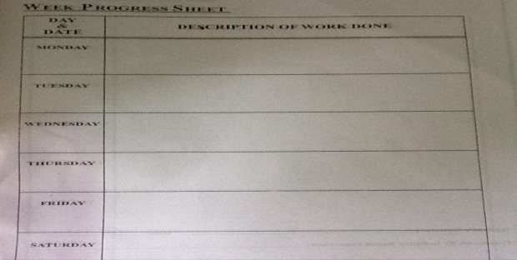

***Fig 1: Scanned student logbook***

The proposed system will give access to free flow of activities in the SIWES organization. Extra added featured to the proposed system include the following:

1. A section where the monthly reports of all the daily activities being carried out in the SIWES INDUSTRY is provided.
2. Availability of the TETFUND section where student can fill the required form in other to amass cash from the TETFUND association.
3. Students are also required to upload a passport photograph picture on the portal each.
4. A feedback section is also created, which enables student to report any disturbances found in the organisation where they are currently undergoing their SIWES programme.
5. A dedicated comment field is also created for staffs or workers around the student, to drop a comment on the performance of the student in the office.

**3.1.2 Historical Background of the case study (LASU)**

The Students Industrial Work Experience Scheme (SIWES) is a new Directorate under the Vice-Chancellor’s Office.  It was established on 20th April, 2012

The Students Industrial Work Experience Scheme (SIWES) is a skills training programmedesigned to expose and prepare students of universities and other tertiary institutions for the Industrial Work situation they are likely to meet after graduation.  It is also a planned and structured program based on stated and specific career objectives which are geared towards developing the occupational competencies of participants (Mafe, 2009).  Consequently, the SIWES programme is a compulsory graduation requirement for all Nigerian university students offering certain courses.

The Students Industrial Work Experience Scheme (SIWES), is the accepted training programme, which is part of the approved Minimum Academic Standard in the various degree programmes for all Nigerian Universities.  The scheme is aimed at bridging the existing gap between theory and practice of Sciences, Agriculture, Medical Sciences (including Nursing), Engineering and Technology, Management, and Information and Communication Technology and other professional educational programmes in the Nigerian tertiary institutions.  It is aimed at exposing students to machines and equipment, professional work methods and ways of safeguarding the work areas and workers in industries, offices, laboratories, hospitals and other organizations.

Prior to establishing the Scheme, industrialists and other employers of labour felt concerned that graduates of Nigeria Universities were deficient in practical background studies preparatory for employment in Industries and other organizations.  The employers thus concluded that the theoretical education being received in our higher institutions was not responsive to the needs of the employers of labour.  Consequently, the rationale for initiating and designing the scheme by the Industrial Training Funds ITF, in 1973.

The scheme is a tripartite programme involving the students, the universities and the employers of labour.  It is funded by the Federal Government and jointly coordinated by the Industrial Training Fund (ITF) and the National Universities Commission (NUC).

1. To provide an avenue for students in the Nigerian universities to acquire industrial skills and experience during their course of study;
2. To prepare students for the work situation they are likely to meet after graduation;
3. To expose the students to work methods and techniques in handling equipment and machinery that may not be available in their universities;
4. To allow the transition phase from school to the world of working environment easier and facilitate students’ contact for later job placements;
5. To provide students with an opportunity to apply their theoretical knowledge in real work situation thereby bridging the gap between theory and practice.

**ORGANISATIONS INVOLVED IN THE MANAGEMENT OF SIWES PROGRAMME AND THEIR ROLES**  
  
The Federal Government, the Industrial Training Fund (ITF), the Supervising Agency, National Universities Commission, NUC, Employers of labour and Institutions have specific roles to play in the management of SIWES.  The roles are:

**1.       The Federal Government**

1. To provide adequate funds to the ITF through the Federal Ministry of  Industry for the  scheme;
2. To make it mandatory for all ministries, companies and parastatals to offer places to students in accordance with the provisions of Decree No. 47 of 1971 as amended in 1990;
3. . Formulate policies to guide the running of the scheme nationally.

**2.       The Industrial Training Fund (ITF).**  This agency is to:

1. Formulate policies and guidelines on SIWES for distribution to all the SIWES participating bodies;
2. Provide logistic material needed to administer the scheme;
3. Organise orientation programmes for students prior to attachment;
4. Provide information on companies for attachment and assist in industrial placement of students;
5. Supervise students on Industrial attachment;
6. Accept and process Master and Placement lists from institutions and supervising agencies;
7. Vet and process students’ logbooks and ITF Form 8.

**3.       The Supervisory Agencies (NUC, NABTEB, etc)**

The NUC is to:

1. To ensure the establishment and accreditation of SIWES unit/Directorate in institutions under their jurisdiction;
2. To vet and approve Master and Placement lists of students from participating institution and forward same to ITF;  
   Fund SIWES Directorate adequately in participating institutions;
3. To direct for the appointment of full-time SIWES Coordinator/Director;
4. Review programmes qualified from SIWES regularly;
5. Participate in the Biennial SIWES conferences and seminars in conjunction with ITF.

[1-15]

**3.1.3 Evaluation of the current system**

The current system was developed in order to enhance the manual task of carrying out SIWES activities such as registration, dissemination of information, filling of log book for students’ day-to-day activities and supervision/assessment by lecturers and industry-based supervisors. The current system is web-based and allows all tasks to be carried out using the personal computer and the Internet. We digitized the SIWES logbook and assessment forms for filling by students and grading by the supervisors electronically. This will allow supervisors to be assigned immediately the students commence their industrial training and facilitate their monitoring in real-time. With the availability of the current system, important messages can be broadcast to all students at once and on a prompt and regular basis.

The current system requires a stable internet connection to be able to carry out its task, the web-based application will be implemented using Java script, HTML and CSS while the programming will be done with PHP programming language and MYSQL will be used for the database. Waterfall software development life cycle will be used in the current system.

However, an evaluation on how some aspect of SIWES processing will be more effective if automated or more effective if done manually would be considered. Moreover, after effective sourcing of information a final decision as been evaluated to affirm to the fact that the current system would be of advantage more than that of the manual system.

**3.1.4 Benefit of the current system**

The current system is a web-based platform that provides employees, customers and suppliers with a single access point to information. A web portal can be used to provide the user with personalised information such as employee training, safety manuals or a customer’s profile. A web-portal can also be used to enhanced the collaboration of information and improve the way employees, customers and suppliers interact with your business. Basically, the current system has a beneficial impact in the SIWES management system which would be further expatiated below:

1. **DATABASE FLEXIBILITY:** In most cases, the manual method being implemented also requires database system which is very ethic and cumbersome because numerous students’ files would be detailed and bonded in a paper-form file which can be mistakenly lost due to careless act. However, the current system has been able to relief the problem being faced by implementing easy storage and retrieval of information in the computerized database.
2. **DIGITALIZE ACTIVITIES:** Basically, all activities being carried out in the SIWES organisation are done manually imposing stress to the student and lecturers. Introducing this current system aid to digitize all procedures carried out by students and lectures.
3. **COST REDUCTION:**Enormous amount of money is being spent by student and lecturers in the course of undertaken SIWES programme, lectures often pay for transportation to check on a particular student he / she is supervising. Student also have to submit numerous forms, printing out document and making photocopies just to partake in the SIWES programme. However, the current system has minimized the whole cost by reducing the cost on transportation, it enables lectures to supervise a student with just logging into the system portal without moving an inch. It also aids student, giving them the ability to submit all their document online without going through the stress of moving down to a particular location to submit. Also, student would no longer be needed to pay just to get a log book.
4. **IMPROVEMENT IN COMMUNICATION:** Lectures might have difficulty communicating with their students under their supervision if the contact is not properly taken, but with the current system,

important messages can be broadcast to all students at once and on a prompt and regular basis.

1. **REDUCTION IN LOSS OF DOCUMENT:** A manual student log book can be missing or wet or probably rough which might after the student educationally making him or her to start all over, but the current situation keeps all students and lecturers records safe and secured without any fear of losing the whole file.

However, the major importance of the current system to students is to reduce the burden of having to manually submit documents to their supervisors in school by providing a platform where the can send those documents via the system, however for the lecturers, it enables quick and easy management of students account and review of SIWES reports

**3.1.5 Problems of the current system**

Every system or medium has benefit also alongside with the bottle-neck engulfed. Developing this current system is a key strategic technology decision that will impact the entire SIWES management, but decision on a portal strategy requires careful analysis of long-term and short-term needs. The current system is a web-based system which will require some features to start up and run effectively. Below I shall buttress on the bottle-neck of the current system which is as follows:

1. **CAPITAL COST:**To start up a web-based system effectively in order for people to access it publicly is a task which require some capital fees for the web-hosting and the domain of the particular website. These fees vary depending on how ethic the website is, but to be on a safer side, a standard web-hosting would be required to start up an effective web-based system which requires money involved.
2. **DEBUGGING ISSUES:** The current system is created using JavaScript, HTML, CSS for the frontend phase of the system and applying PHP, MYSQL for the backend phase of the system. The languages listed can produce various bugs which can be stressful and time consuming. The server-side language “PHP” tends to provide numerous bugs if not properly taken care of.
3. **TRAFFIC ISSUES:** In the current system, if the physical memory usage and the I/O (Input & Output) usage is low, students and lecturers won’t be able to have access to the web-portal, which can cause problem for both the lecturers and the student. A website with a low band-width can also suffer crashes due to high traffic, if this aspect of the web-portal is not properly taken care of, it can cause big problems in the future.
4. **HIJACKERS:** Basically, in the internet world today there are various hackers all over looking for web-portal to break into, this is a very critical case in the current system. If the current system is being hacked the whole system would be rendered useless. Poor SSL SECURITY management can lead to loss in the nearest future.
5. **POOR INTERNET:** Internet is a vital medium needed to access the web-portal system, without a good internet connection there would be no access to the web-portal medium which can cause delay. This issue can affect both the lecturers and the students, which would make all the procedures needed to be performed on the portal by both lecturers and student slow.

However, other issues that can cause problem to the current system is the **DESIGN INTERFACE**. The web-portal must be a easy-to-use website in other for student and lecturer to easily grasp how the environment works. A bad GUI (Graphic User Interface) would make communication difficult and it will make it difficult for both student and lecturers to flow freely in the environment.

**3.1.6 Technical Details of the solution to the problem**

In every problem, there is always a solution indulge to it, the current system has some bottle-neck that can be totally prevented if these technical preventive measures can be considered. However, we shall discover different ways to prevent any of the problem that might come up with the current system. The following are technical ways to prevent and solve the problems associated with the current system:

1. **STRONG CAPITALIZATION:** In otherto prevent future problems or disruption of the web-portal, laying a solid foundation for the portal is a very good move in order to prevent issues. Creating a solid web-host for the website and a very standard band-width would make the website to be free from issues of traffic and also reduce the risk of crashes on the web-portal.
2. **INDEPTH KNOWLEGDE ON THE PROGRAMMING LANGUAGES:** Having a thorough knowledge on the languages that would be used to develop the web-portal is an important case. This is very helpful to make the web-portal organised and also helps to reduce the difficulty in debugging issues. Once in-depth knowledge is acquired it would be very easy for the programmer to scale through bugs that will surely come up in the development phase of the web-portal.
3. **ADVANCED SSL CERTIFICATE:** This is a vital measure that must be done in-order to prevent loss of the web-portal, purchasing a web-hosting service that provide this feature is very important. Why is this needed? This is very crucial because it will help to protect the website against hijackers and internet fraudsters that are roaming about everywhere, therefore keeping your web-portal safe and sound without any issues. Security is one of the most commonly overlooked aspects of most web-portals, until you get a major security scare! Hackers and cyber criminals can give any company or firm a headache, but sadly people tend to realise the true value of security following a difficult or costly episode. Preventing this at first would surely keep the portals free from any problems.
4. **MONITORING THE WEB-PORTAL:** Daily check-up on the web-portal is a very good way to reduce risk of having problems in the web-portal. Understanding the site is a vital case which must be done majorly by the administrator of the site. This would enable the site to be active and also reduce risk of sudden crashes.
5. **EASY-TO-USE-ENVIRONMENT:** The developer of the web-portal should take cognizance of the GUI (Graphics User Interface) or layout of the web-portal. The web-portal should be descriptive enough for students and lecturers to have free flow understanding on how the website works. Basically, the web-portal tour video can be viewed for freshers on the website to give students and lecturers a vast knowledge on how the website works.

**3.2 SYSTEM DESIGN**

**3.2.1 Overview of the new system**

Software system design is a creative activity in which software components and their relationships, based on a customer’s requirements are identified. It is the process of defining the component modules, interfaces and the architecture of the system to satisfy the user requirements.Systems design is the process of defining elements of a system like modules, architecture, components and their interfaces and data for a system based on the specified requirements. It is the process of defining, developing and designing systems which satisfies the specific needs and requirements of a business or organization.

A systemic approach is required for a coherent and well-running system. Bottom-Up or Top-Down approach is required to take into account all related variables of the system. A designer uses the modelling languages to express the information and knowledge in a structure of system that is defined by a consistent set of rules and definitions. The designs can be defined in graphical or textual modelling languages.  
Some of the examples of graphical modelling languages are  
a. Unified Modelling Language (UML): To describe software both structurally and behaviourally with graphical notation.  
b. Flowchart : A schematic or stepwise representation of an algorithm.  
c. Business Process Modelling Notation (BPMN): Used for Process Modelling language.  
d. Systems Modelling Language (SysML): Used for systems engineering.  
Design methods:  
1) Architectural design: To describes the views, models, behaviour, and structure of the system.  
2) Logical design: To represent the data flow, inputs and outputs of the system. Example: ER Diagrams (Entity Relationship Diagrams).  
3) Physical design: Defined as a) How users add information to the system and how the system represents information back to the user. b) How the data is modelled and stored within the system. c) How data moves through the system, how data is validated, secured and/or transformed as it flows through and out of the system.

**SOFTWARE PROCESS MODEL**

In order to integrate the current system in the SIWES management, the developer must integrate with a development strategy that include the process, method and tools layer and generic phases. This strategy is basically known as process model or a software developing paradigms. This project would lay focus on the **Waterfall Model**.

**WATERFALL MODEL**

The waterfall model is a classical model used in system development life cycle to create a system with a linear and sequential approach. It is termed as waterfall because the model develops systematically from one phase to another in a downward fashion. This model is divided into different phases and the output of one phase is used as the input of the next phase. Every phase has to be completed before the next phase starts and there is no overlapping of the phases.

**Description:**The sequential phases described in the Waterfall model are:  
1. Requirement Gathering- All possible requirements are captured in product requirement documents.  
2. Analysis Read - the requirement and based on analysis define the schemas, models and business rules.  
3. System Design -- Based on analysis design the software architecture.  
4. Implementation Development of the software in the small units with functional testing.  
5. Integration and Testing Integrating of each unit developed in previous phase and post integration test the entire system for any faults.  
6. Deployment of system - Make the product live on production environment after all functional and non-functional testing completed.  
7. Maintenance Fixing issues and release new version with the issue patches as required.

**ADVANTAGES OF THE WATERFALL MODEL**

1. The waterfall model is a very simple model which is very easy-to-use, simple and understandable, the simplicity of this model makes it easier to implement the current system
2. The waterfall model is also easy to manage as each phase has specific outputs and also a review process.
3. This model consists of clearly defined stages.
4. It also works well for smaller projects where requirements are very clear
5. In the waterfall model, the process and outputs are of each phase are clearly mentioned in the document.

**DISADVANTAGES OF THE WATERFALL MODEL**

1. The waterfall model also has some drawbacks but basically one of the paramount drawbacks is it doesn’t allow much reflection or revision. When the product is in testing phase, it is very difficult to go back and change something which is left during the requirement analysis phase.
2. In the waterfall model, risk and uncertainty are high.
3. The waterfall models is not really advisable for complex and object-oriented projects.
4. When dealing with this model, changing requirements can’t be accommodated in any phase.
5. As testing is done at a later phase. So, there is a chance that challenges and risks at earlier phases are not identified.

However, after a critical review of the benefits and drawbacks of the **Waterfall Model**, a final decision to initiate the waterfall model on the current system as been made. This model is chosen above every other model because it is easy to use and its drawbacks mostly affects object-oriented project which does not seem to be our case study in this project.

**3.2.2 Output design**

**Use Case Diagram:** The use case model of the UML is used to specify the functionality of the system from the users’ point of view and show the way the system and the users interact to achieve its stated functions and perform its goal. The figure below shows the use case diagram for the SIWES portal.

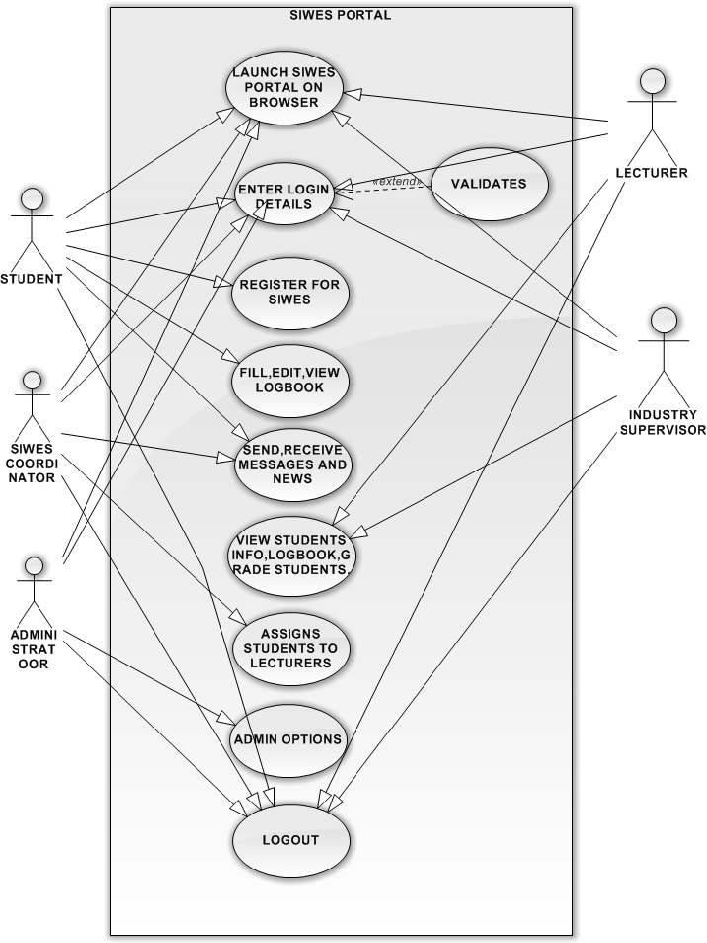

From the description above, the students are required to launch the SIWES portal on a web browser, after which they enter their login details which would be validated by the system. Students are to register for SIWES and fill up the required form stipulated. Thereafter, the students are required to fill, edit and view their logbook easily, and they can easily log out from their profiles once they are done with their activities.

The SIWES coordinator also need to launch the SIWES portal on a browser, thereafter enter their login details and carry out activities such as sending and receiving messages and news to the student and lecturers. Afterwards, they can also assign students to lecturer on the web-portal and also log out after carrying out any activity.

The administrator would also be required to launch the SIWES portal on a web browser, enter their login details and they’re also given the privilege to visit the admin options panel and make changes to the web-portal and log out after every activity.

The lecturers are also entitled to launch the SIWES portal on a web browser, enter login details also view the student’s information, logbook and thereafter, grade the students and log out. The industry supervisor also has access to visit the web-portal.

**3.2.3 Input design**

**Class Diagram**

Class diagrams are the most popular UML diagrams used by the object-oriented community. It describes the objects in a system and their relationships. Class diagram consists of attributes and functions. A single class diagram describes a specific aspect of the system and the collection of class diagrams represents the whole system. Basically, the class diagram represents the static view of a system. The class diagram for the SIWES portal is shown below.

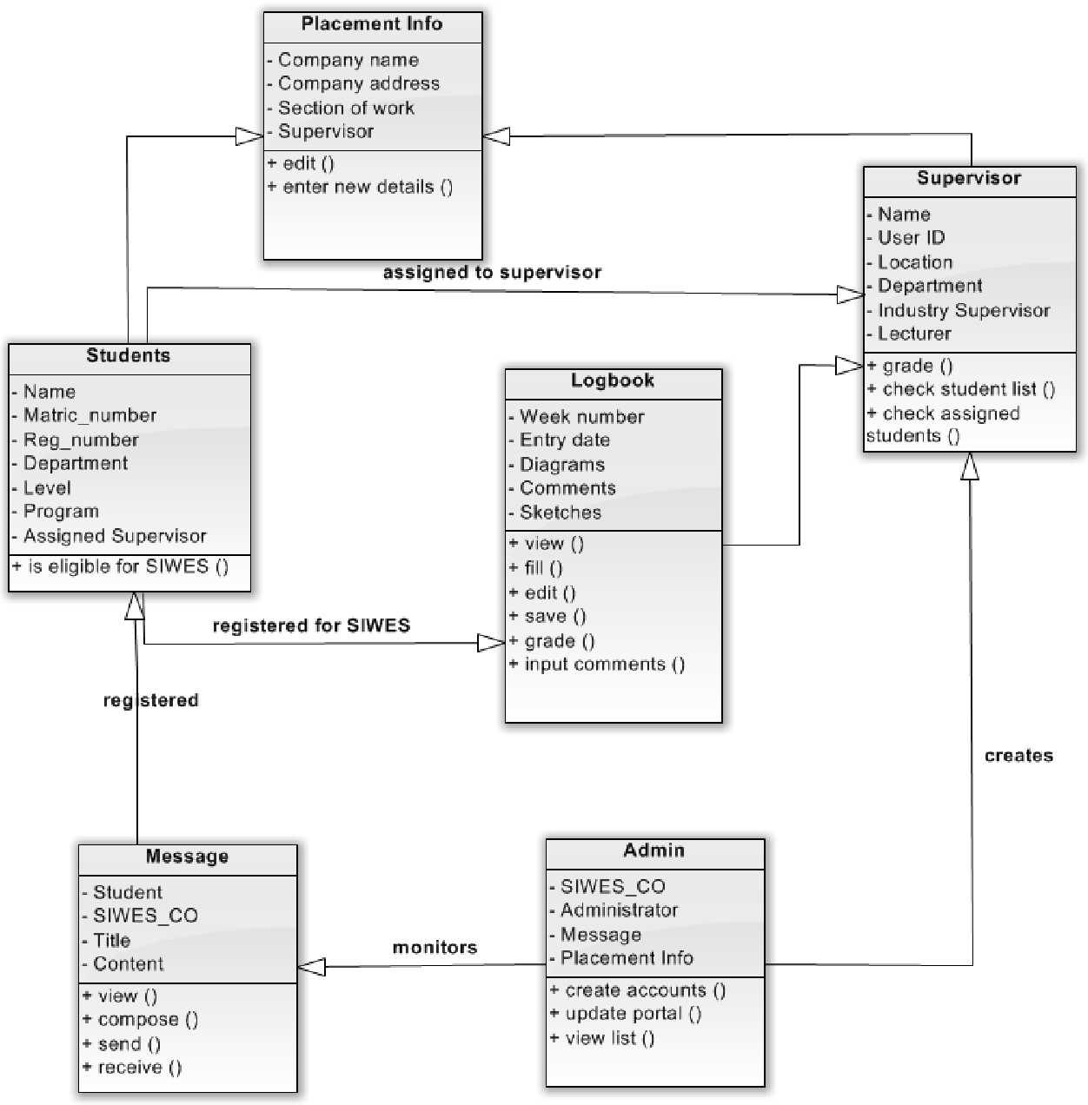

**User or Web Interface Design**

The Web portals are primarily made up of dynamic web pages. Dynamic means that the user interacts more with the web site, beyond just reading the pages and the web site responds accordingly. Usually, a web server delivers the web pages that have been built and hosted on the server, has an IP address and might have a domain name.

The SIWES portal contains about a total of 30 wen pages ranging from the Home page, About page, Team page, Student page, FAQ’s, Lecturer login page, Industry-Based-Supervisor login page, Admin page, SIWES coordinator page and so on. The pages are designed using a text-editor known as Visual Studio Code and Brackets which both provide PHP, HTML and CSS capabilities. Also, jQuery was used to ensure that empty fields are not sent to the web browser in processing a form.

**3.2.4 Database**

A **database** is an organized collection of [data](https://en.wikipedia.org/wiki/Data_(computing)), generally stored and accessed electronically from a computer system. Where databases are more complex they are often developed using formal [design and modelling](https://en.wikipedia.org/wiki/Database#Design_and_modeling) techniques.

Databases are mostly central to web portals. A database can hold almost any collection of information you may want to search and update, such as a user list, names of products or a list of various items. The database used in this work is MySQL which is a relational database. It is accessed using the graphical user interface provided by the PhpMyAdmin tool. The phpMyAdmin allows MySQL database to be administered through the web browser.

The PhpMyAdmin works locally which allows the developer to develop the web portal locally before finally moving it up to the live host. The database is very essential in the modification of the web-portal due to the fact that, all students, lecturers, administrator and SIWES coordinators details and activities would all be stored in the database. The database serves as the backbone of the web-portal, all works are being stored and it makes it easy to be able to reference any work or activities done in the past.

In the current system, I shall be interacting with the database with MYSQL and PHP programming languages which can be used to manage the website effectively. PHP serve as a server-side programming languagewhich can only run on an environment either a localhost or a live-host.

However, below is the diagrammatic expression of the outlook of this project database design

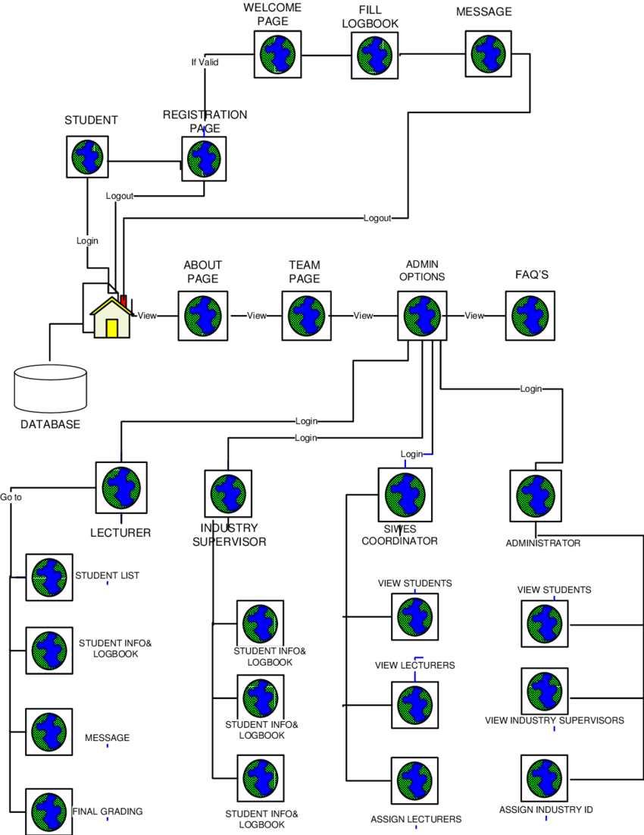

The above diagram descriptively explains how the database of this project work, revealing the different table sections that would store all activities performed. In the above description, the major (PK) primary key used for this web-portal to uniquely identify students is basically their matriculation number. Also, lecturers ID are also used to uniquely identify lecturers in a particular university.

**3.2.5 Process Design**

**Sequence Diagram**

A **sequence diagram** shows object interactions arranged in time sequence. It depicts the objects and classes involved in the scenario and the sequence of messages exchanged between the objects needed to carry out the functionality of the scenario. Sequence diagrams are typically associated with use case realizations in the [Logical View](https://en.wikipedia.org/wiki/4%2B1_architectural_view_model) of the system under development. Sequence diagrams are sometimes called **event diagrams** or **event scenarios**.

Sequence diagrams show the relationships between the objects participating in a given use case and they help to identify interaction between objects. Figure 3 describes the sequence diagram of the student (a use case actor), the portal system and the database.

In Figure 3, for the student to log into the portal, the database checks for user authentication and grants the user access into the system. He can then register for SIWES, fill his logbook,view the logbook or send and receive messages.

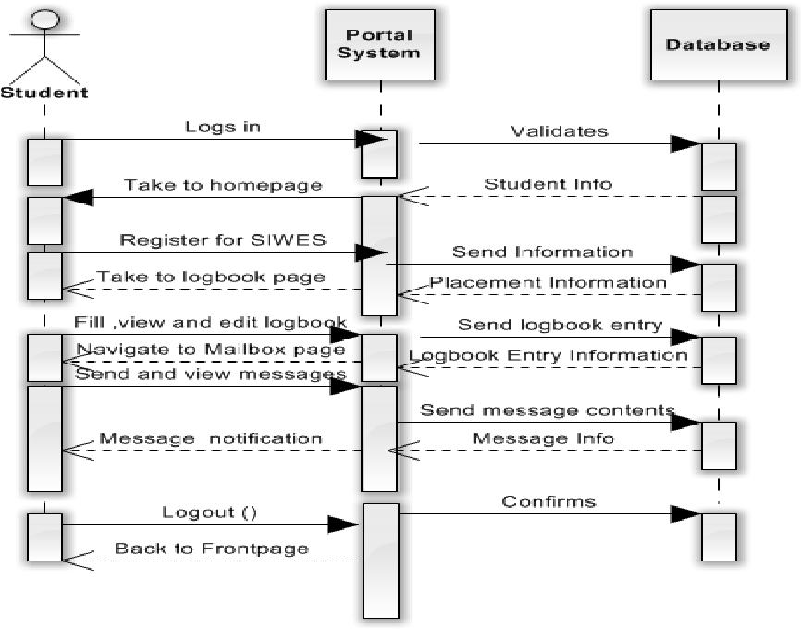

**Activity Diagram**

**Activity diagrams** are graphical representations of [workflows](https://en.wikipedia.org/wiki/Workflow) of stepwise activities and actions[[1]](https://en.wikipedia.org/wiki/Activity_diagram#cite_note-1) with support for choice, iteration and concurrency. In the [Unified Modelling Language](https://en.wikipedia.org/wiki/Unified_Modeling_Language), activity diagrams are intended to model both computational and organizational processes (i.e., workflows), as well as the data flows intersecting with the related activities.Although activity diagrams primarily show the overall flow of control, they can also include elements showing the flow of data between activities through one or more data stores.

Activity diagram is another important diagram in UML to describe dynamic aspects of the system. Activity diagram is basically a flow chart to represent the flow from one activity to another. The activity can be described as an operation of the system.Therefore, the control flow is drawn from one operation to another. This flow can be sequential, branched or concurrent . Figure 4 shows the activity diagram of a student navigating through the SIWES portal.

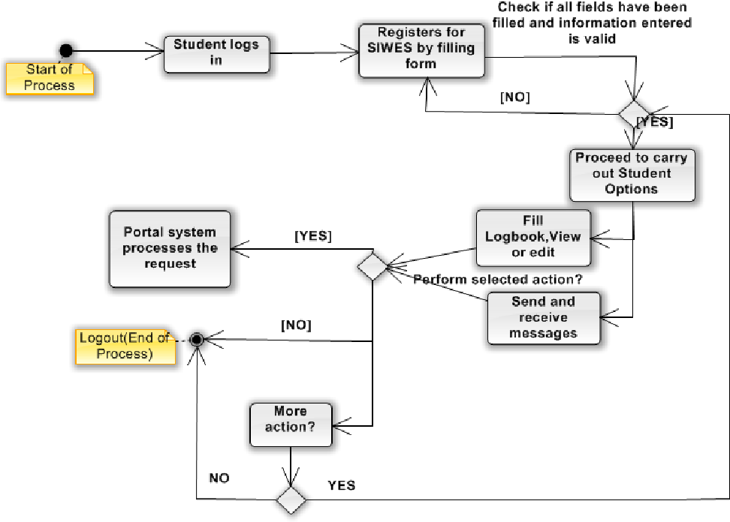

**CHAPTER FOUR**

**SYSTEM ANALYSIS AND DESIGN**

“Implementation is a realization of a technical specification or algorithm as a program, software component, or other computer system through computer programming and deployment”. (Smith, 2001). This chapter will focuses on the implementation of the electronic logbook for SIWES.

* 1. **Choice Of Programming Language**

PHP was chosen for the design and implementation of some of the components of the Electronic logbook due to its robust built-in functions that provides the capability of executing commands that enables interaction with the database, especially in the aspect of posting and retrieving form details. PHP is object oriented, supports inheritance or usability of codes, it is highly popular and used in most web application development, well documented and has good support libraries and it integrates very well with Hypertext Markup language (HTML), the main language for designing user interfaces.

The front-end of the application (the GUI that the user utilizes to interact with the databases) is achieved using HTML, CSS and Java Script programming languages. MySQL database engine was used. It was chosen due to its generality and simplicity compared to others.

* 1. **Choice Of Database Management System**

The choice of database management system chosen to run this program is known to be “XAMPP”. It is a free and open-source cross-platform web server solution stack package developed by Apache Friends, consisting mainly of the Apache HTTP Server, MariaDB database, and interpreters for scripts written in the PHP and Perl programming languages. Since most actual web server deployments use the same components as XAMPP, it makes transitioning from a local test server to a live server possible.

The following are the database table created and the function they perform each:

**User form:** The user’ database holds the username and password of all users of the logbook. Access is denied or granted based on a match between the user entered values and the values stored in the database.

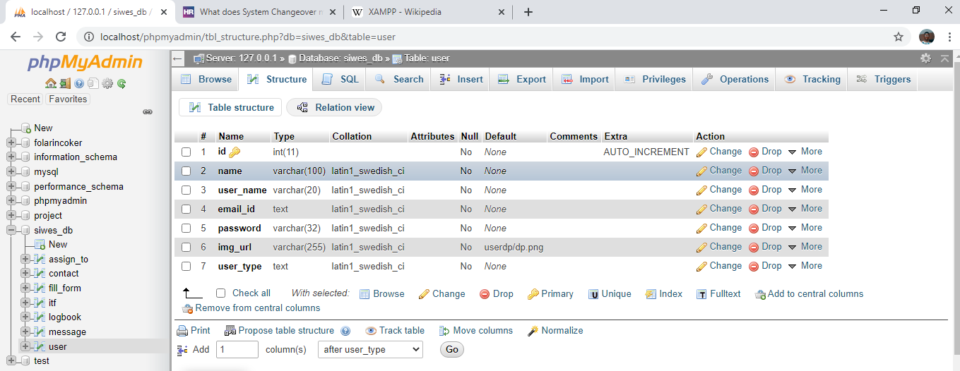

**Fig1 : The user’ database.**

**Registered Student’s For Siwes Form (Fill_Form Table):** The table contains all personal information submitted by the student that has successfully registered for SIWES. Such information include the student’s name, matriculation number, etc.

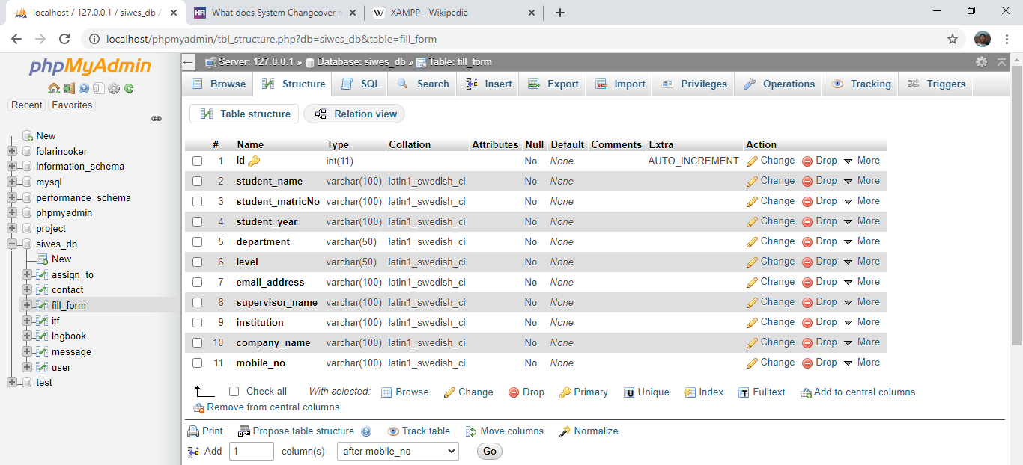

**Fig2 : The Registered Student For SIWES’ database.**

**The E-Logbook Table:** The database of the logbook table contains all the daily experiences logged in by the student. Students daily data are being stored in the logbook table sequencially.

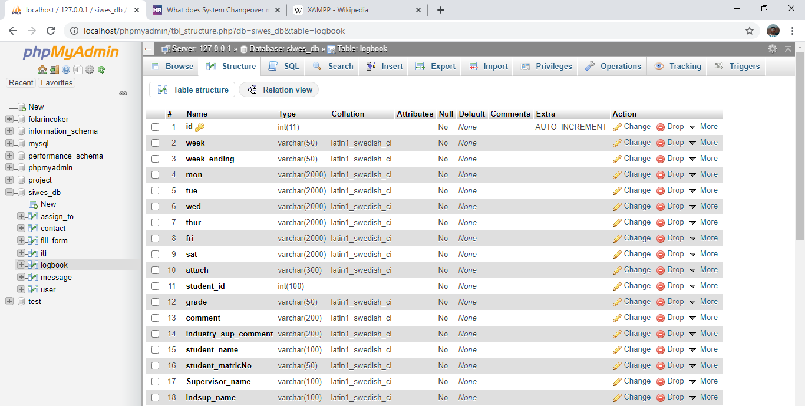

**Fig 3 : The Student Logbook database.**

**ITF form:** The ITF form is a form that is attached to the logbook and is expected to be filled by all students by the end of the training period.

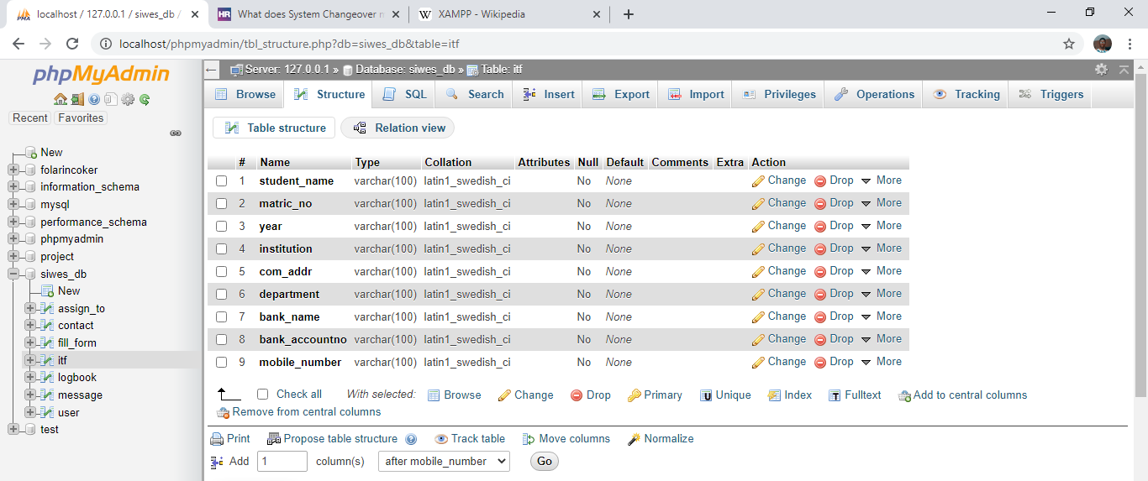

**Fig 4 : The ITF form database.**

**Assign Table:** The Assign table relate with the registered student table and the user table, it is created to enable siwes coordinator assign students to their corresponding lecturers/Supervisor.

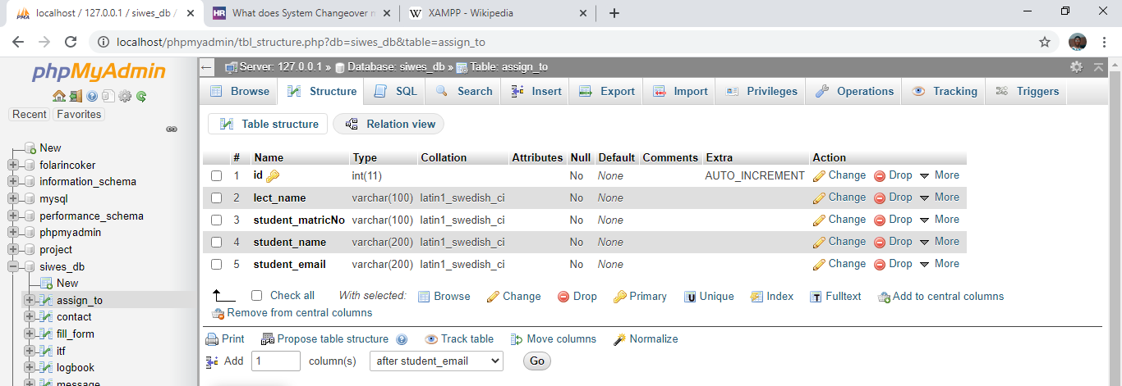

**Fig 5 : The assign_to database.**

**Contact Table:** This field is created in other to receive feedback from users of the logbook portal in case their’s a bug that is needed to be fixed.

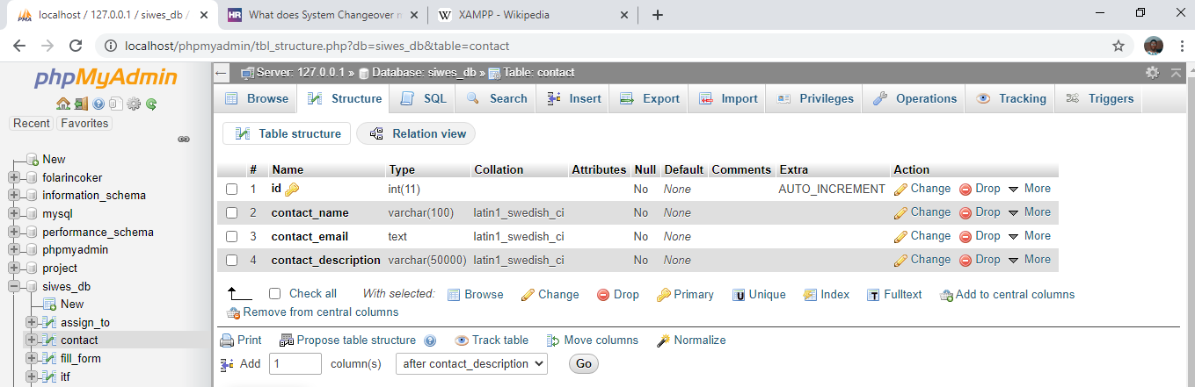

**Fig 6: The contact table database.**

**Message Table:** This table was created in other to allow communication between all the users of the system and to allow free flow communication with supervisor’s and the student.

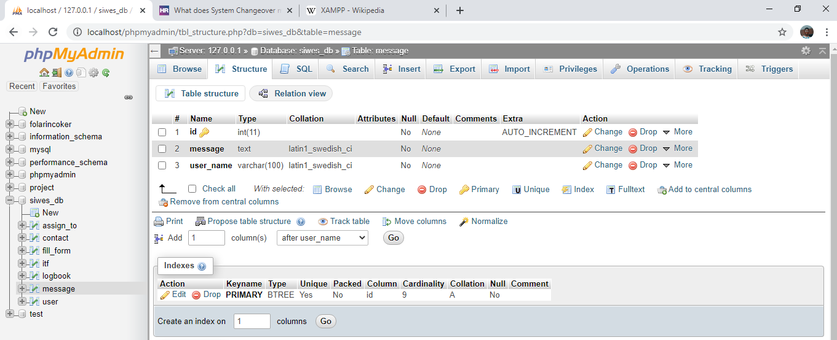

**Fig 7: The message table database.**

* 1. **System Requirement**

In computing, it is believed that for an application to run on a system effectively, it needs minimum software and hardware component that it will require in order run. The software and hardware requirement for this application is stated below.

* 1. **Hardware Requirement**

Hardware, in computer world refers to the physical components that make up a computer system, they are usually connected together to create a complete system.

The minimum hardware requirements for the system are:

1. Screen Resolution Recommended (1280 X 800) Minimum of (1280 X 270)

2. 256MB Random Access Memory (RAM Size)

3. 128 MB Hard Disk Drive

4. Pentium 3 Central Processing Unit

* 1. **Software Requirement**

Software are applications that runs on a system; they can only be seen but not cannot be touched. The software requirements for this application are:

1. Windows XP Operating System or Higher Microsoft Windows OS

2. A web browser

3. XAMPP Server installed on your machine cause the database is locally created.

* 1. **System Testing**

System testing is the testing of a complete and fully integrated software product. Usually software is only one element of a larger computer based system. Ultimately, software is interfaced with other software/hardware systems. System testing involves a series of different tests whose sole purpose is to exercise the full computer based system.

Unit testing deals with testing a unit as a whole. This would test the interaction of many functions. This would test the interaction of many functions but confine the test within one unit. Table 4.1 shows the unit test of the system; i.e. the test data, thee expected result and the actual result. When a user fills the login form with the correct data, it is expected that the page will be redirected to another page based on the login type. The result of the test is the redirection of the page to another, based on the login type.

Table 1.1 Unit testing. The Test Data, Expected Data, and Actual Result

|  |  |  |
| --- | --- | --- |
| The Test Data | Expected Test Result | Actual Test Result |
| Home Page | The page where you can navigate to other pages | The home page |
| Login page | The page where users are redirected to other pages | The login page |
| Registration Page | This is where all user’s of the logbook portal register according to their status as student, lecturer, industry supervisor or siwes coordinator | Their details would be stored in the database |
| Siwes Registration Page | Students are expected to register for siwes before they can access their electronic logbook | Students information submits to database |
| Chat-Bot Page | This page allows communication to flow between all the user’s of the logbook portal | All messages submits to the database and are displayed on every user chat-bot screen |
| Siwes Coordinator Page | The Siwes coordinator is expected to assign student to their respective lecturer | An intermediate table is created to assign the student’s to lecturer and submit details in the database |
| Lecturer’s Page | The lecturer is expected to grade students under his/her supervision. | The students under the lecturer logbook data are populated on the lecturer page and can be graded respectfully by the lecturer |

**The Test Data**

During the testing of the proposed system, the following were targeted:

1. The fully integrated software applications including the external computer peripherals devices, were tested in order to check how components interact with one another and with the system as a whole (This is also called End to End scenario testing)
2. Verification through thorough testing of every input in the application to check for desired outputs.
3. Testing of the user’s experience with the proposed system application.
4. Building of detailed test cases and test suites that test each aspect of the application as seen from the outside without looking at the actual source code.
   1. **File Conversion**
   2. **System Change Over**

System changeover is concerned with the smooth shift from one way of doing things to another and the mitigation of disruption to business activities during the changeover. There are three main methods used: phased implementation, direct changeover and parallel running.

* **Phased implementation:** a staged method whereby one part of the overall system that need changing is changed. If any problems arise, they are limited in scope and therefore non-critical. Once the system has been successfully changed in one area, the other areas can follow suit, with any lessons learned during the initial changeover

used to ensure the success of the changeover as a whole.

* **Parallel running:** Both the old and the new systems run side-by-side, using live data, so that project managers can compare the efficiency and reliability of the new system. Once they’re satisfied, the old system is taken offline and the new system becomes fully active and utilized across the organization.
* **Direct changeover:** there’s a single, fixed point where one system stops being used and the new one becomes live. This is the cheapest, quickest and easiest form of system changeover but is also the riskiest – if the system is broken or inefficient, the whole organization suffers.

The system change over which was applicable to the current system is known to be the **“Direct Change Over”.** The old system make use of the manual method of approach towards SIWES MANAGEMENT SYSTEM, but with this new system which digitalized the whole process eradicate all manual process in the old system.

* 1. **System Documentation**

The result of this phase consists of source code, together with documentation to make the code more readable. For software implementation the software does not only have to be considered from the point of view of logistics functionality but from the technical perspective. So if a company works with old software, it may want to use a new system, which is more efficient and has more work capacity.

The implementation of the Electronic Logbook for SIWES was done through the utilization of both the PHP Rapid Application Development tool and MySQL Database System. CSS, HTML, JAVASCRIPT was also used for the browser side interfaces. PHP was chosen to implement the programming logic of the system while the XAMPP server/MySQL database system provided the auxiliary storage unit for the information about the system.

In this section, the Electronic logbook for SIWES user interfaces will be presented along with the specifications and requirements necessary to run the system in its intended area of application.

The following are the screenshots for the logbook interfaces.

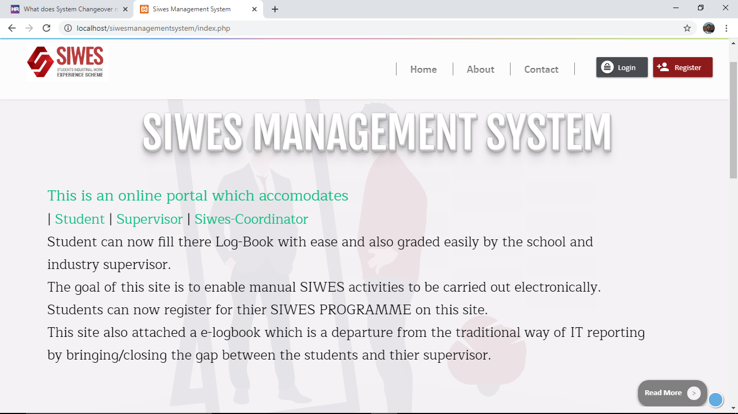



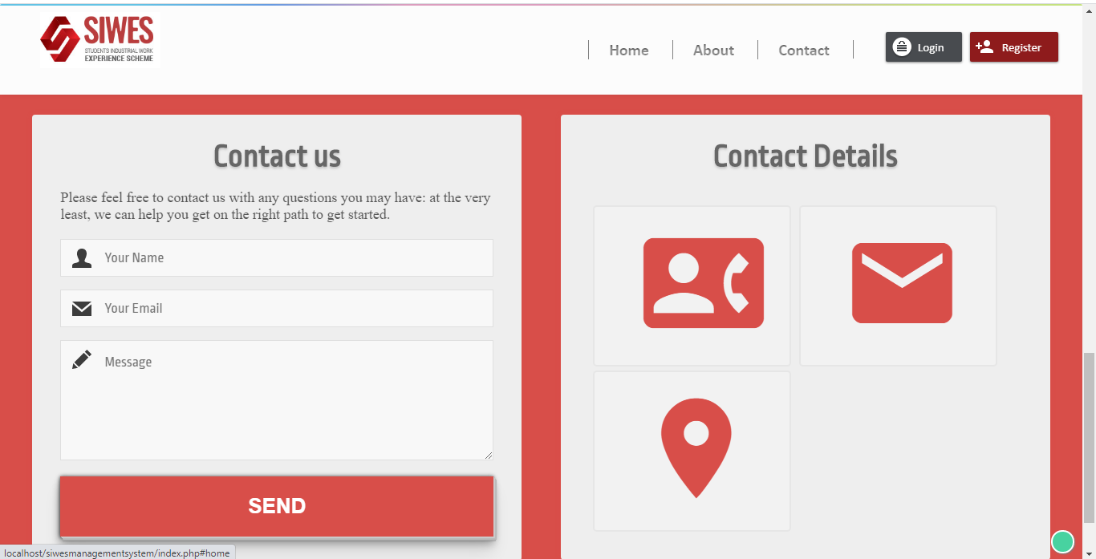

Fig 8.1: The Home Page

**The Home Page:** The Home Page is where users gains access to all the functionalities of the Electronic Logbook System. After the application is launched, the interface in Fig 4.1 is presented to the user. This interface contains links to other pages which are made available to a user based on predefined access privileges. Fig 4.1, also contain links to external websites and do not require any login to use. The Home page contains such links as Home, Login, Logout and Lesson Area. In other words, this interface, being the main interface, allows users to navigate to all the functionalities of the application depending on your access privileges.

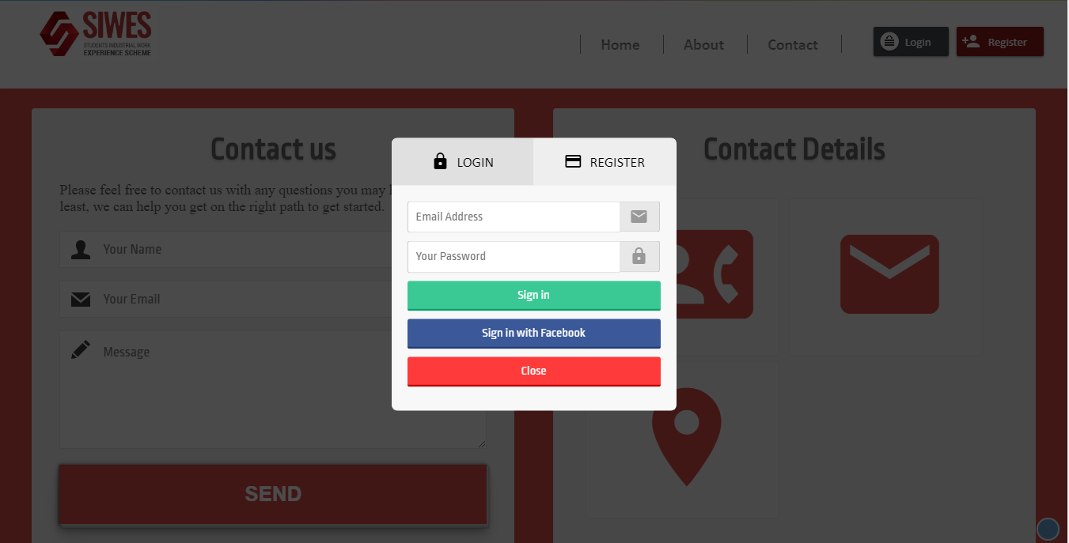

Fig 8.2: The Login Window

**The Login Window:** The login window contains a Login form that is made up of two input fields, the Username field and a Password field. It also contains a Submit button for submitting user inputs. This page redirects a user to a page that depends on his role in the application architecture. A user may login as student, a supervisor, a school coordinator, or an ITF official. Logging in any of these name will redirect the user to a page that he is entitled to view and interact with.

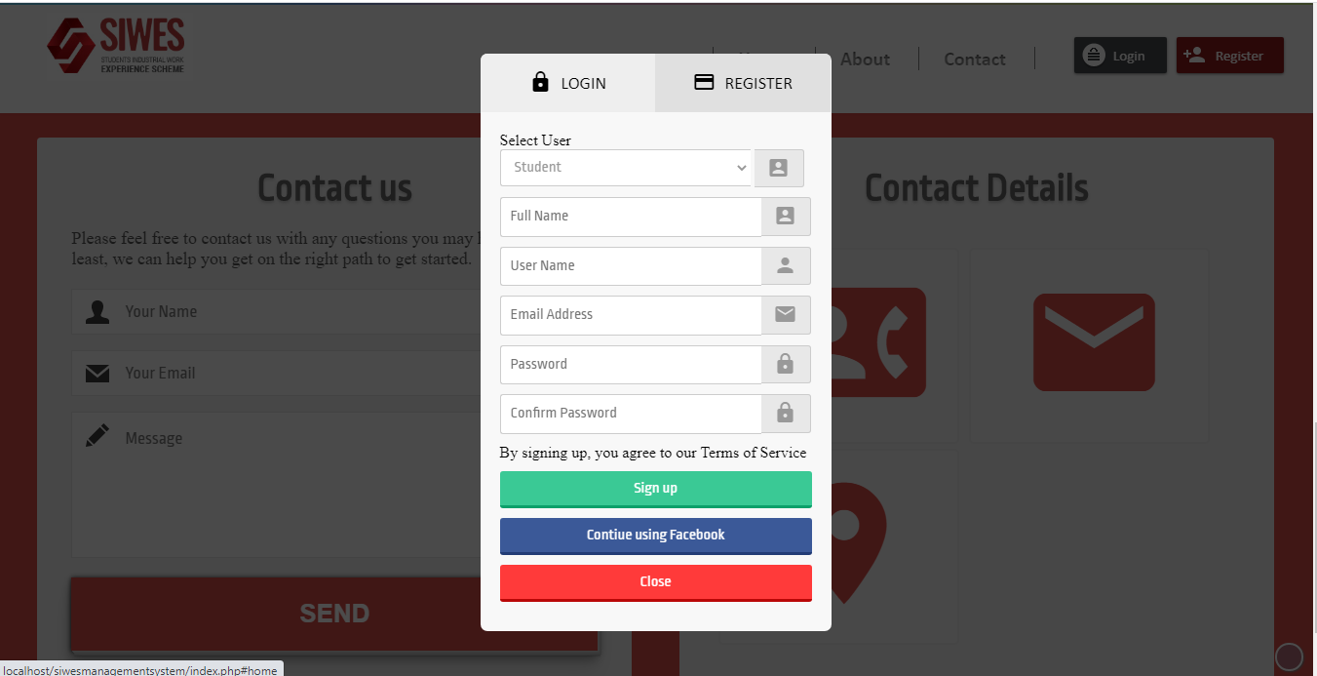

Fig 8.2: The Registration Window

**The Registration Window:** The registration window contains a registration form that takes in all user data and also request user to select their status either as a student, lecturer, siwes coordinator, industry supervisor, administrator respectively. User will be able to login successfully after registration.

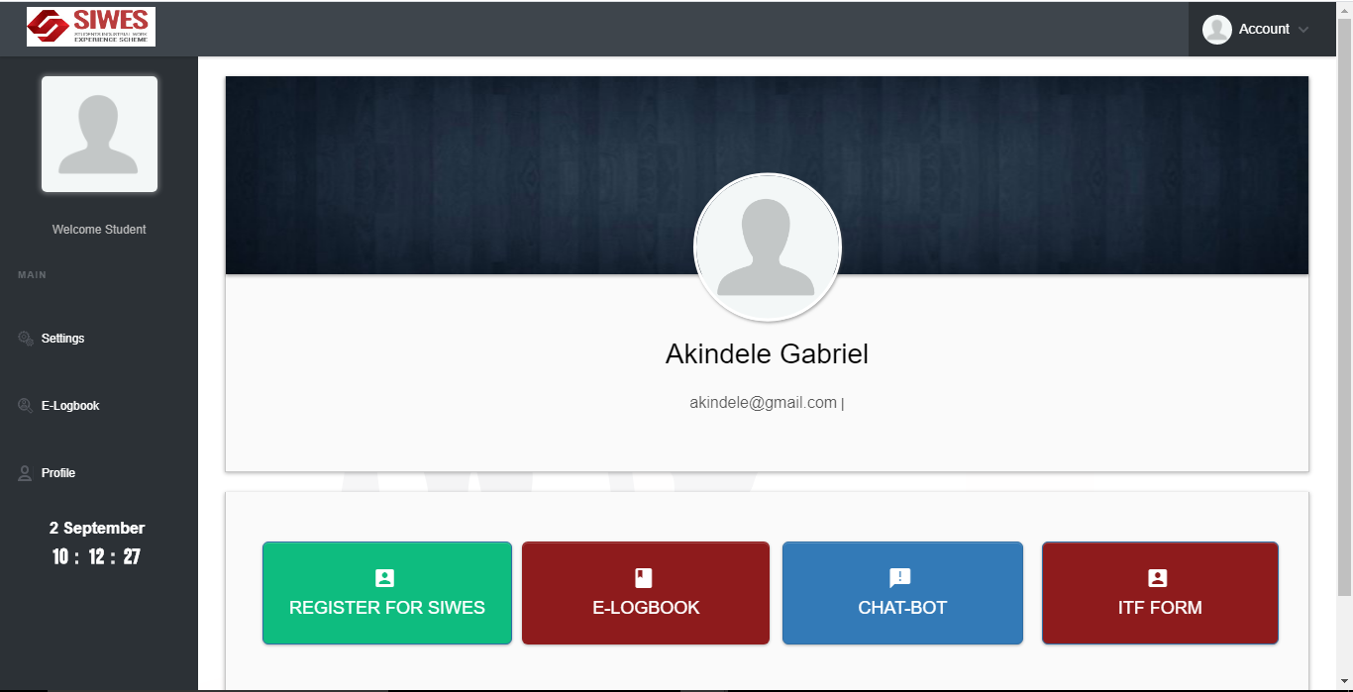

Fig 8.3: The Student Dashboard

**The Student Dashboard:** The student dashboard consists of four sections. Students are allowed to register for their SIWES programme before accessing their logbook, the logbook section will be opened after a student successfully register for SIWES.

The chat-bot section enable students to communicate with other users of the system and ask questions when they’re confused. The ITF section collates students bank information and SIWES INDUSTRIAL information in other to process funds for the student undergoing SIWES.

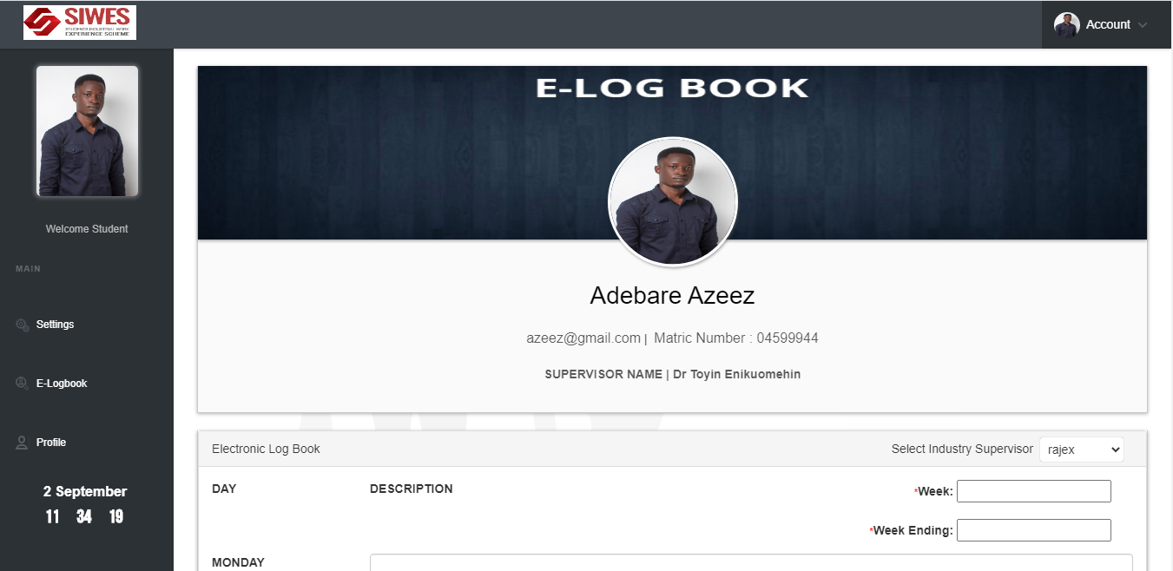

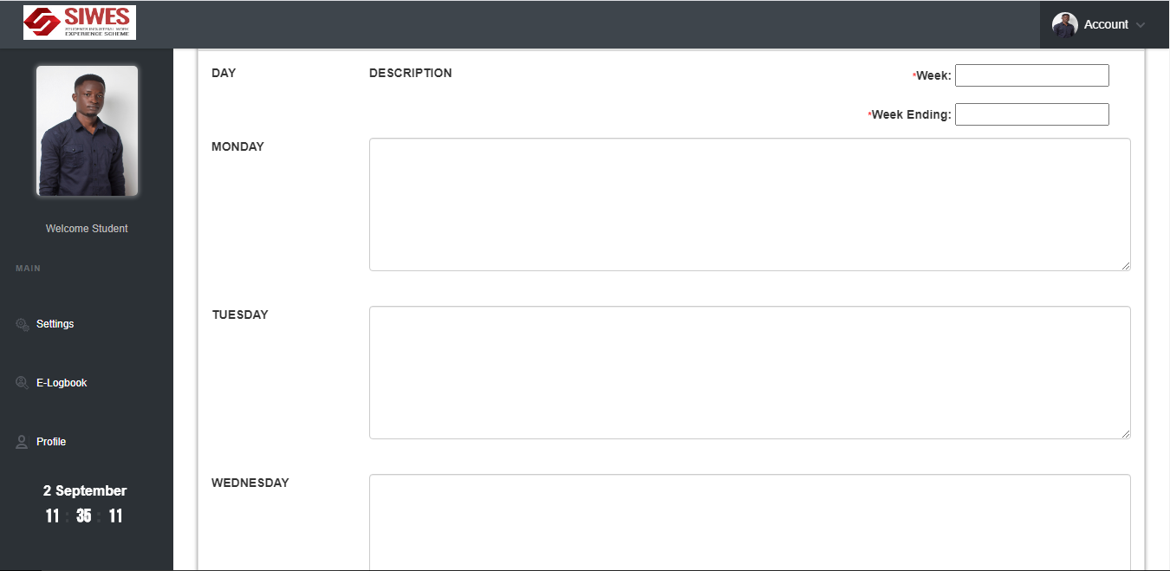

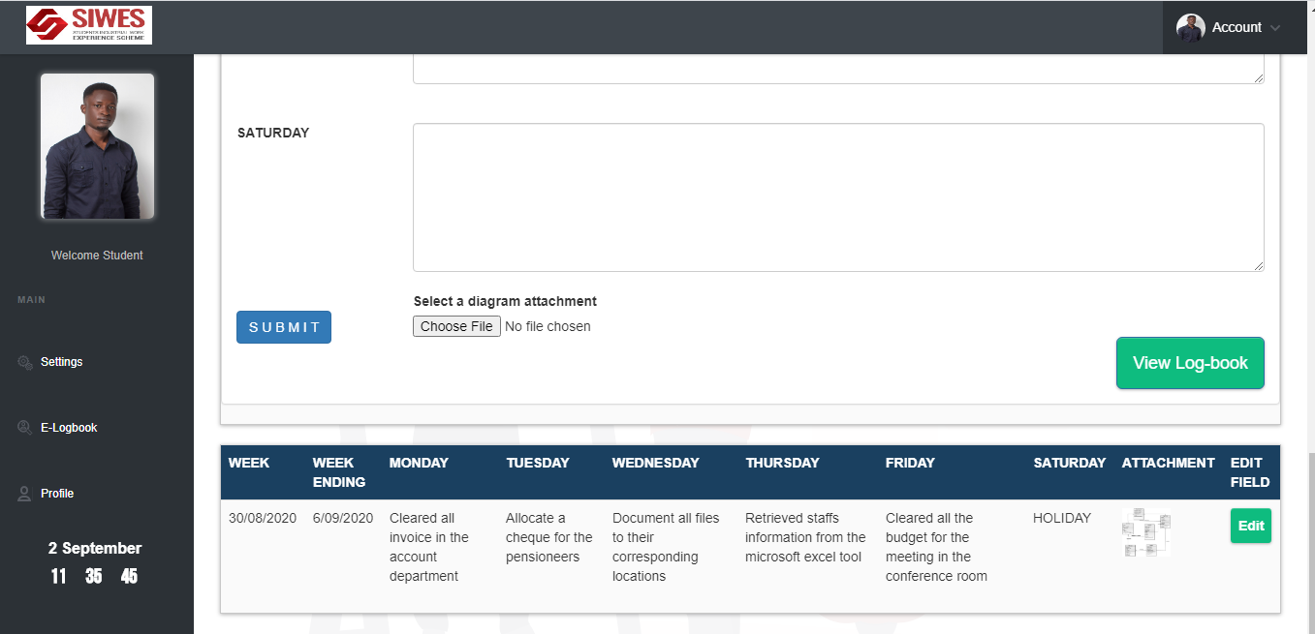

Fig 8.4: The LogBook Page

**The E-Logbook Page:** The students are required to fill their weekly activities in this section and submit all details which would be stored in the database and student can also be able to add diagram attachment to their weekly report which will be used for grading.

Students also have the ability to edit their logbook just in case there is a mistake somewhere. All changes made would be collated and updated in the database.

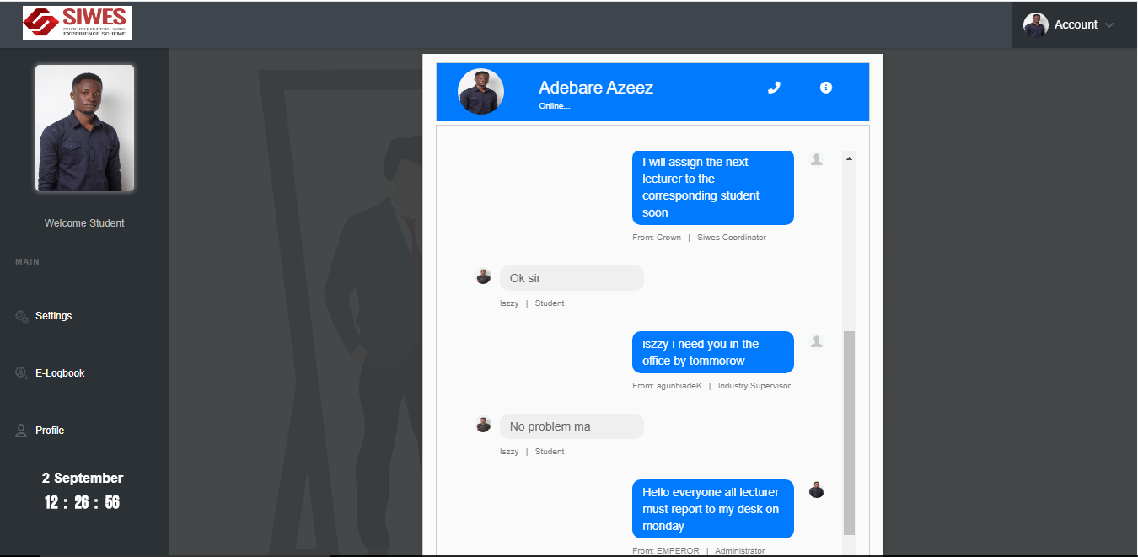

Fig 8.5: The Chat-Bot Page

**The Chat Bot Page:** The chat-bot section is created to enable free-flow communication between the lecturer, students, industry supervisor, siwes-coordinator and administrator. Announcements can be made and message can be passed across to every user of the platform.

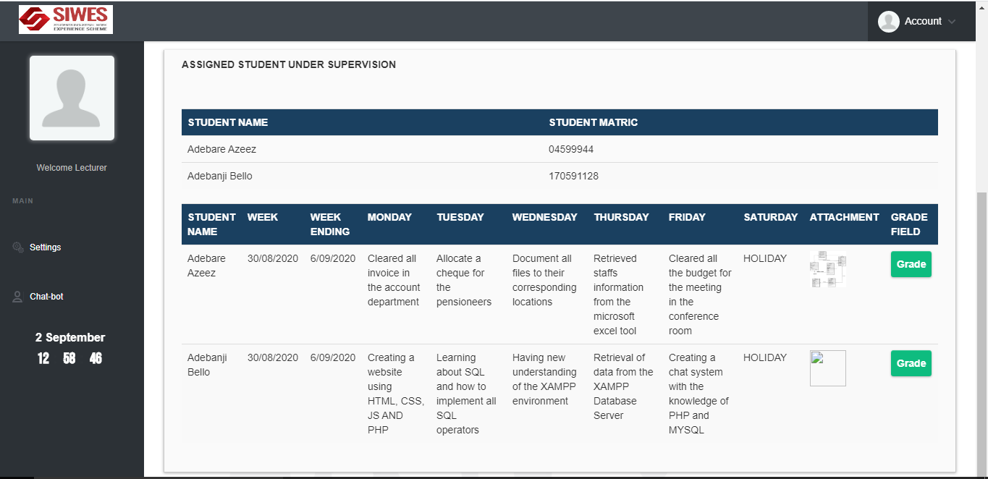

Fig 8.6: The Supervisor/Lecturer Page

**The Supervisor Page:** In the supervisor’s page, student under supervision details are being displayed on the page and the supervisor can grade student based on his/her performance in each weekly report.

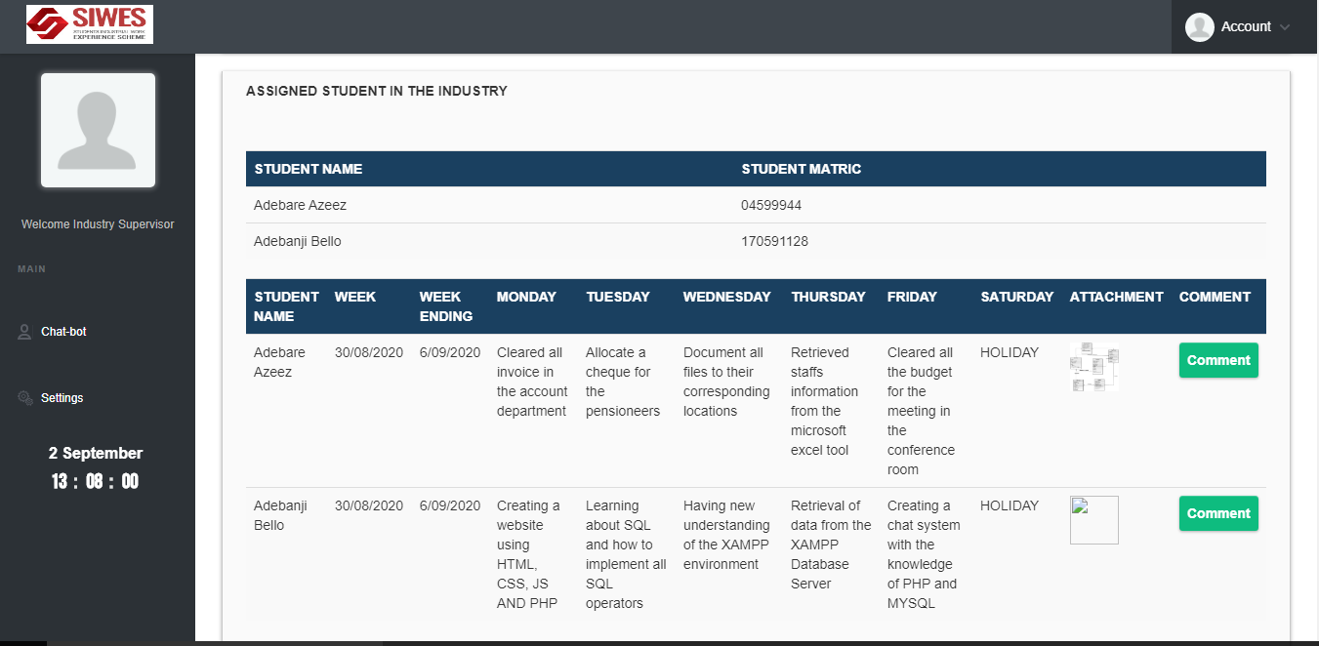

Fig 8.7: The Industry Supervisor’s Page

**The Industry Supervisor Page:** In the industry supervisor’s page, student under supervision in the industry details are being displayed on the page and the industry supervisor can leave a comment on student based on his/her performance in the Industry.

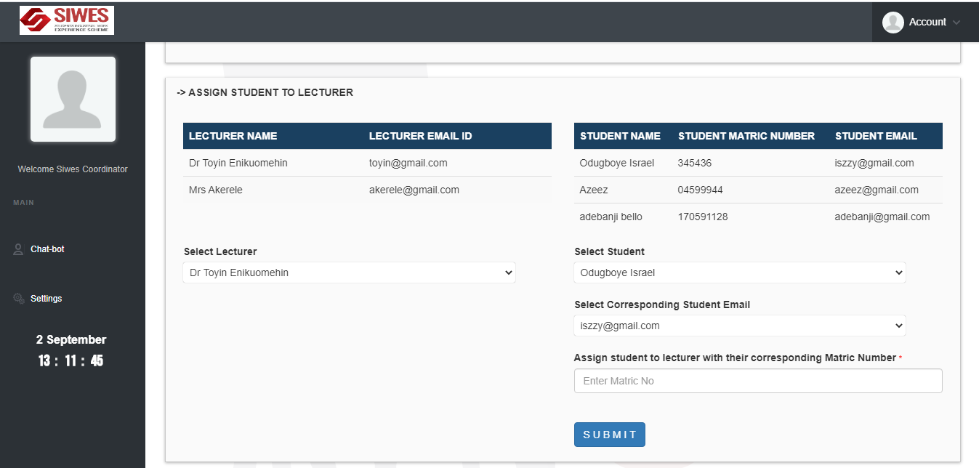

Fig 8.7: The SIWES Coordinator’s Page

**The SIWES Coordinator’s Page:** In the SIWES coordinator’s page, lecturers are being assigned to students respectively. This section will submit student details to their supervisor, the intermediary table created in the database controls the process at which students are being assigned to their corresponding supervisor.

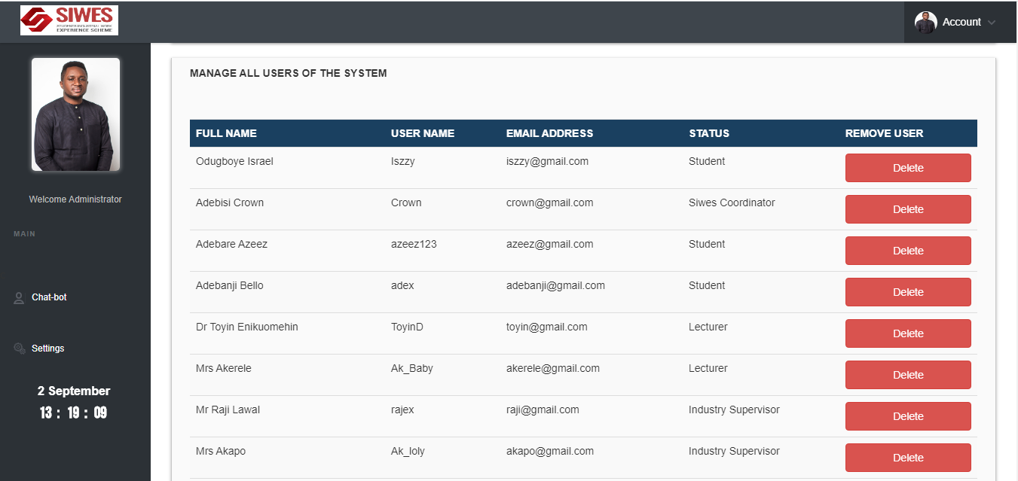

Fig 8.8: The Administrator’s Page

**The Administrator’s Page:** The administrator has access to all the information of the entire user in the platform and also manages all users by removing any user from the platform.

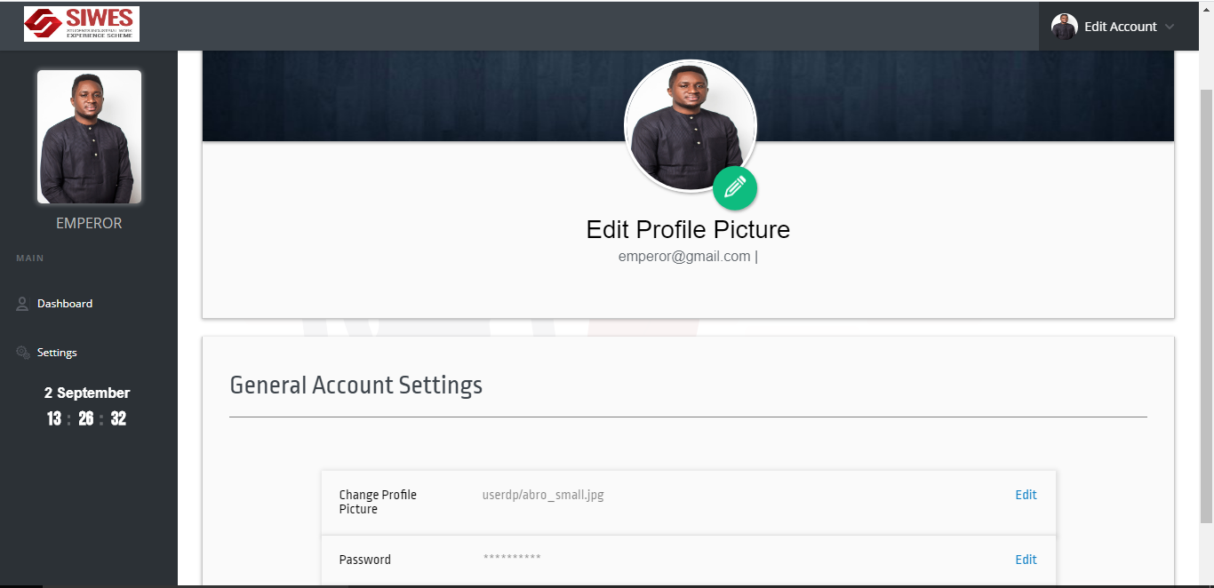

Fig 8.9: The Settings Page

**The Settings Page:** All users have access to this page, users can perform numerous operation on this page such as changing their profile picture, changing their account details and all.

**CHAPTER FIVE**

**SUMMARY, CONCLUSION AND RECOMMENDATIONS**

* 1. **Summary Of Findings**

The SIWES MANAGEMENT SYSTEM draws inspiration from the traditional paper logbook and is designed to solve problems that are associated with the traditional logbook.

In this project, I added some other functions that enable interns have maximum industrial training experience**.** I have described and analyzed already existing computer systems designed to carter for one problem area or the other and have been able to come out with a system that is adaptable to the Nigerian system. I have also reviewed several literatures related to the area of Electronic logbook and SIWES MANAGEMENT SYSTEM. Ultimately, we applied some of the models to solve the **SIWES MANAGEMENT SYSTEM** problems.

* 1. **Limitations**

Some of the limitations encountered were caused basically because I was working on a local server and the Google map API include to give a location of the developer in the contact us phase could not be implemented.

This project is a study of the usability of electronic logbook and is therefore may not give or meet every expectation. The main focus of the project is to develop a system for reporting IT activities within the university community, other than the paper logbook. Other extended functionality may not therefore be included or where they are, may lack some expected features. Some of the extended features may include:

The ability to tell the number of weeks a student submits his/her weekly work by incrementing a value every time the student submits her work.

The ability to search the web interfaces through a search field may not be possible since the pages are not so many as to warrant a search field.

* 1. **Conclusion**

From the traditional logbook available to us and the already published papers on the area of Electronic logbooks, we have designed an application for managing all the activities being carried out on the SIWES INDUSTRIAL PLATFORM. The software was able to perform the main function which one of it is to log in information about students daily experiences.

* 1. **Recommendations**

The development of any software is not a one-time affair; the reason being that challenges are bound to occur as humans evolves. Efficient result can only be obtained if the logbook is used efficiently and also upgraded when the need arise; therefore it is necessary to make recommendations that will guide computer user as well as the administrators.

It is recommended that the system be adopted since it will save cost and boost the learning experience of interns

The system may be upgraded to suit other needs of the university community, especially as it regards internship

The ITF should adapt the electronic method since ITF forms pass from hand to hand before getting to the officials.

REFERENCES

1. ABDULLAHI, A., *ABDULSALAM ABDULLAHI U10/FMS/BUS/083.* Hypothesis. **5**: p. 1.6.

2. Adamu, U.K., *THE ROLE OF INDUSTRY BASED SUPERVISORS IN IMPLEMENTING SCHOOL–INDUSTRY PARTNERSHIP IN TECHNICAL EDUCATION PROGRAMME.* ATBU Journal of Science, Technology and Education, 2014. **1**(1): p. 17-21.

3. Adetiba, E., V. Matthews, and V. Egunjobi, *ONLINE DEPLOYMENT OF E-SIWES PORTAL FOR STUDENTS’INDUSTRIAL WORK EXPERIENCE SCHEME MANAGEMENT IN COVENANT UNIVERSITY.* 2014.

4. Adetiba, E., et al., *Development of e-SIWES portal: A web based Platform for student Industrial Work Experience Scheme (SIWES) Management.* International Journal of Applied Information Systems, 2012. **3**(8).

5. Babalola, G., O. Adeyemo, and L. Adewole, *Leveraging on Web-based Technology for the Management of Students on SIWES Programme in Higher Educational Institutions (HEIs): A Case Study of Afe Babalola University.*

6. Chukwuedo, S.O., *Students’ perception of the influence of students’ industrial work experience scheme (siwes) on academic achievement in university of Benin.* Journal of Education, Health and Technology Research, JEHER, 1 (1), 2011: p. 80-86.

7. Ikechukwu, C., *Recommended changes in students' industrial work experience scheme (SIWES) geared towards decrease in unemployment rate of business education graduates in Nigeria.* 2016.

8. ITUA, I.O. and E.P. WACHUKWU, *A TECHNICAL REPORT ON STUDENTS INDUSTRIAL WORK EXPERIENCE SCHEME (SIWES).*

9. Izueke, E.M. and I.F. Nzekwe, *Students’ Industrial Work Experience Scheme (Siwes) and Graduate Employability in Nigeria: A Study Of the South East Geo-Political Zone.* Scottish Journal of Arts, Social Sciences and Scientific Studies, 2013. **14**: p. 110-126.

10. Michael, O.S. and K.B. Oluwatosin, *Mobile-based SIWES Placement Recommendation System (A Case Study of Nigerian Universities).* International Journal of Computer Applications, 2016. **152**(9).

11. Ogunde, A.O. and J.O. Idialu, *A recommender system for selecting potential industrial training organizations.* Engineering Reports, 2019. **1**(3): p. e12046.

12. Omonijo, D.O., et al., *The Review of the Student Industrial Work Experience Scheme (SIWES) in Four Selected Countries.* Academic Journal of Interdisciplinary Studies, 2019. **8**(3): p. 158-158.

13. Omoniyi, O.J. and B.C. Elemure, *Challenges of curriculum development in office technology and management in tertiary institutions.* Use of English, 2014. **1**(2): p. 2.

14. Oyeniyi, A.A., *Students' Industrial Work Experience Scheme (SIWES) and the Incidence of Occupational Misfit in Nigeria.* Online Submission, 2012.

15. Zachariah, B. and P.N. Yabuwat, *A Collaborative Students' Industrial Work Experience Scheme (SIWES) Supervision and Management Platform: A Cloud-Based Solution.* International Journal of Advanced Research in Computer Science, 2016. **7**(2).